How to Create Accessible Documents in Microsoft Word

How to achieve checklist item #1: Filename
File > Save OR CTL + S.
Enter a filename using the following rules:
- No spaces
- No special character (underscores and hyphens are okay)
- No unfamiliar abbreviations
Accessible filename Examples:
- SmithB_Resume.docx
- 04-12-16_Meeting_Agenda.docx
- US_History_Report_v1.docx
How to achieve checklist item #2: File Properties
Figure 1
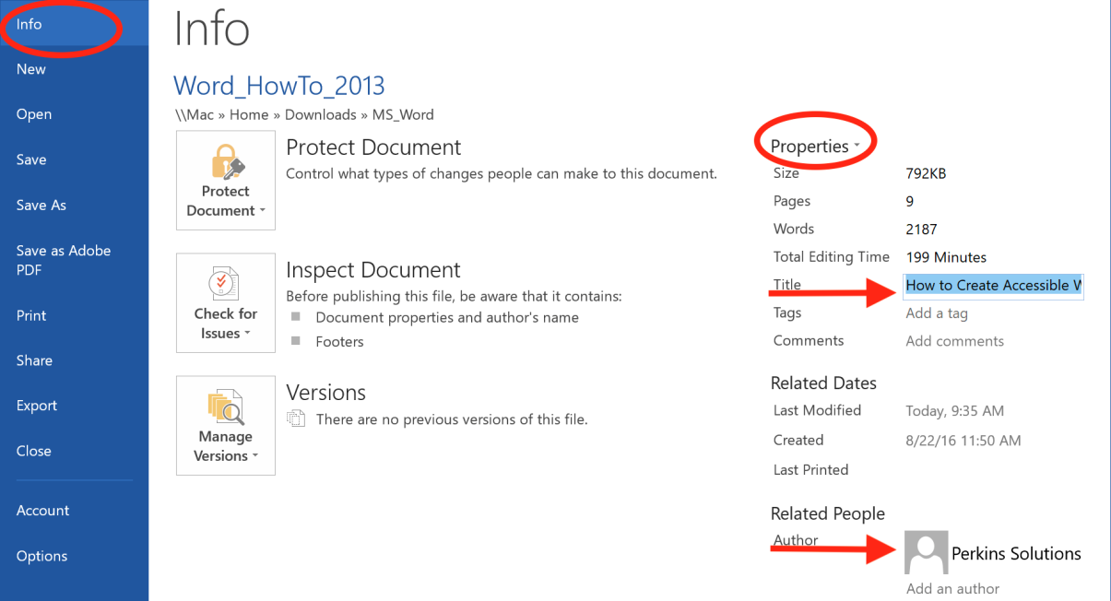

Set Author and Title
File > Info > Properties.
Enter Title and Author information (See Figure 1).
Set Document Language
File > Options > Language (See Figure 2).
Or
Select All.
Select the language displayed in the status bar at the bottom of the document.
Select your language preference.
Figure 2
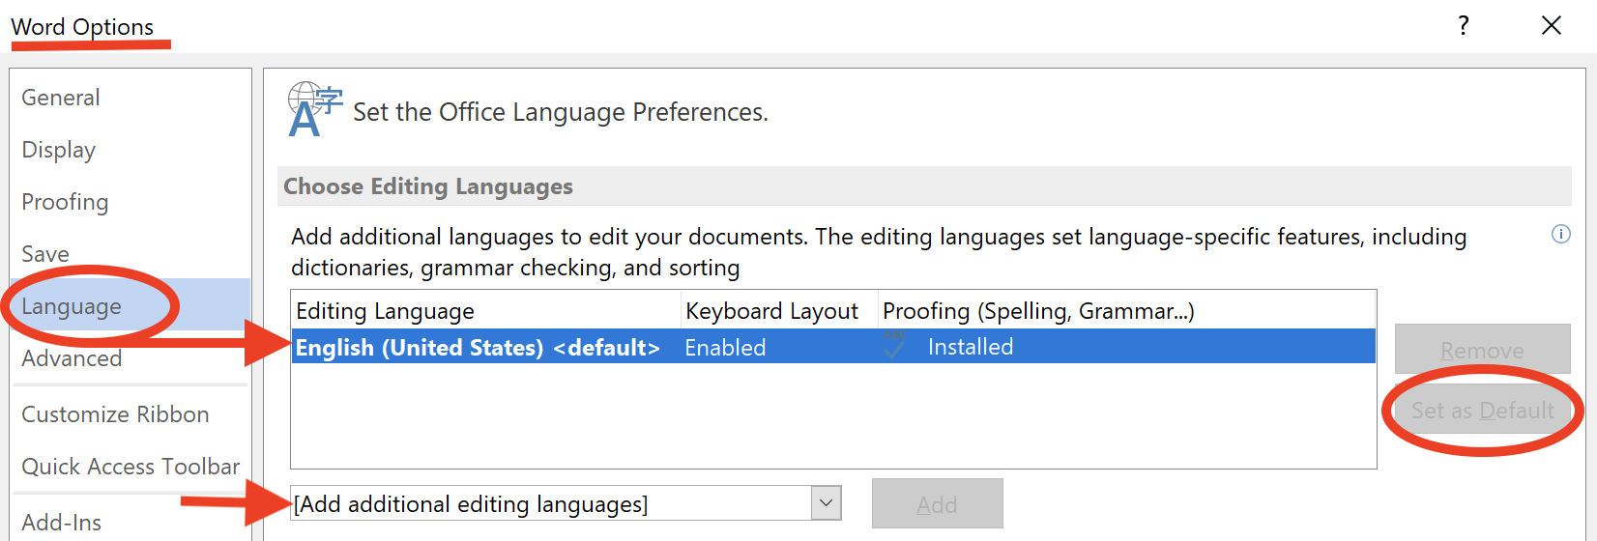

How to achieve checklist item #3: Page Numbers
Insert > Page Numbers.
Select location of page numbers (See Figure 3).
Figure 3
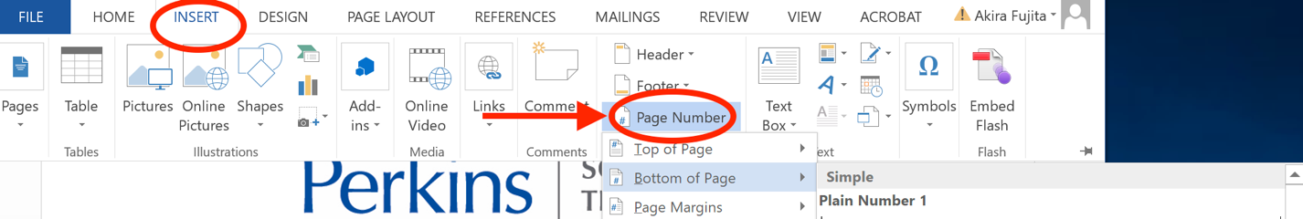

How to achieve checklist item #4: Text

Set Default Font
Home > Fonts OR CTL + D.
Make your selections for font, size, and color.
Select “Set as Default” (See Figure 4)
Figure 4
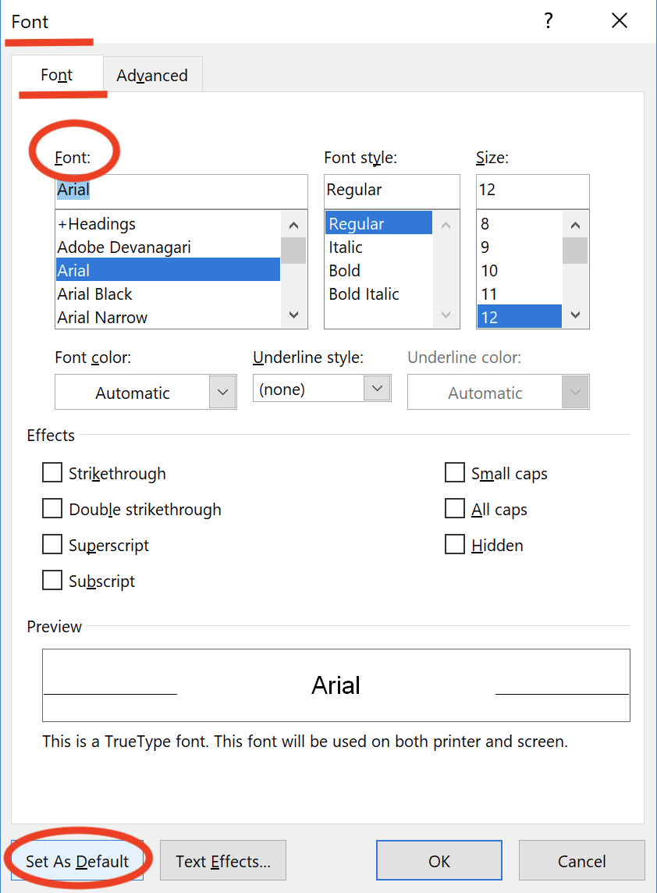

Increase Line-Spacing
Select block of text, or “select all” CRL + A to apply to whole document.
Home > Line and Paragraph Spacing icon.
Select line-spacing preference. Use line-spacing of 1.5 or more whenever possible.

How to achieve checklist item #5: Color
Test contrast ratio using the Colour Contrast Analyzer.
Use a font color that has a color contrast ratio of 4.5:1 for 12 to 14-point font, and 3:1 for 14-point Bold font and larger (See Figure 5).
When color is used to convey meaning or distinguish elements, (e.g. highlighted text), a secondary characteristic must also be used such as an underline.
In charts and graphs, text labels or a secondary visual characteristic (such as a textured fill) must be used.
See “How to achieve checklist item 13”.
Figure 5
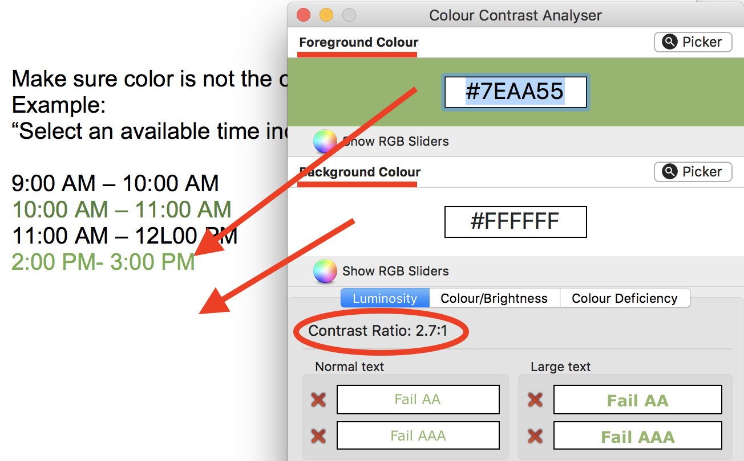

How to achieve checklist item #6: Whitespace

Insert a page break:
Place cursor at the beginning of the line of text that will start the new page.
Insert > Page Break (See Figure 6).
Figure 6
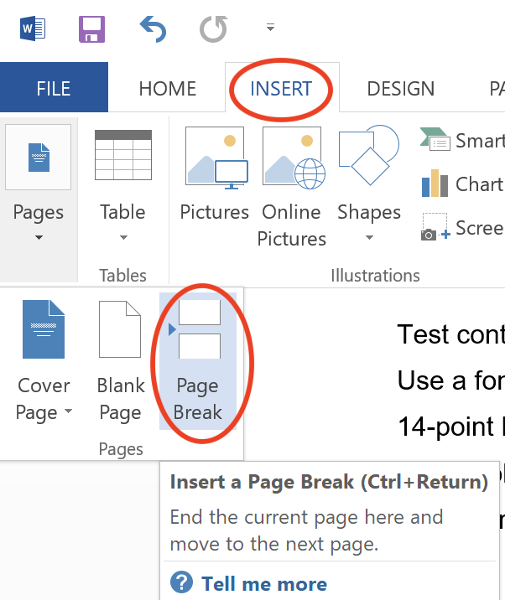

Create Space Between Lines of Text
Select the line of text.
Page Layout > Spacing > increase value of “before” or “after”.
Can also select text, then “right-click” and choose Paragraph.

Create Columns
Select the text you would like to present in columns.
Page Layout > Columns.
Select the preferred number of columns.
Note: Be sure to apply only to selected text unless you want columns for the entire document.

How to achieve checklist item #7: Headings

Apply a Heading Style
Select text to be styled as a heading.
Select heading level in Home > Styles (See Figure 7).
Note: The heading level may change the color of the text. This color may not meet contrast ratio guidelines. It may also not be your color preference.
Figure 7
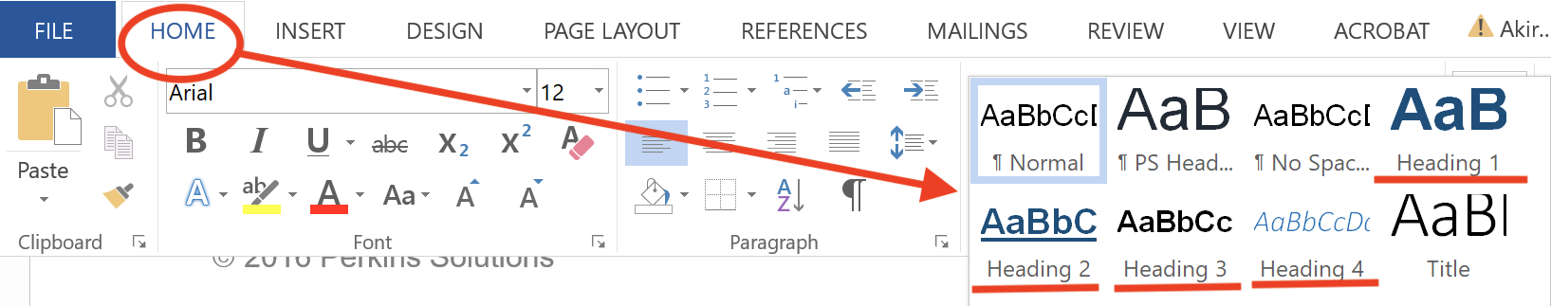

Modify Heading Style
Select the heading/text you want to modify.
Change the font, size, color, etc. using formatting tools in the Home ribbon.
“Right-click” on the heading level in the Styles section and choose “Update to match selection.”

How to achieve checklist item #8: Table of Contents
Note: The document must have semantic heading structure prior to creating a Table of Contents.

Create a Table of Contents
References > Table of Contents > Insert Table of Contents (See Figure 8).
Choose your format preference.
In the “Show levels” field, enter the number of heading levels you would like to appear in the TOC. For example, if you want heading 1 and heading 2 text to appear in the TOC, enter 2

Figure 8
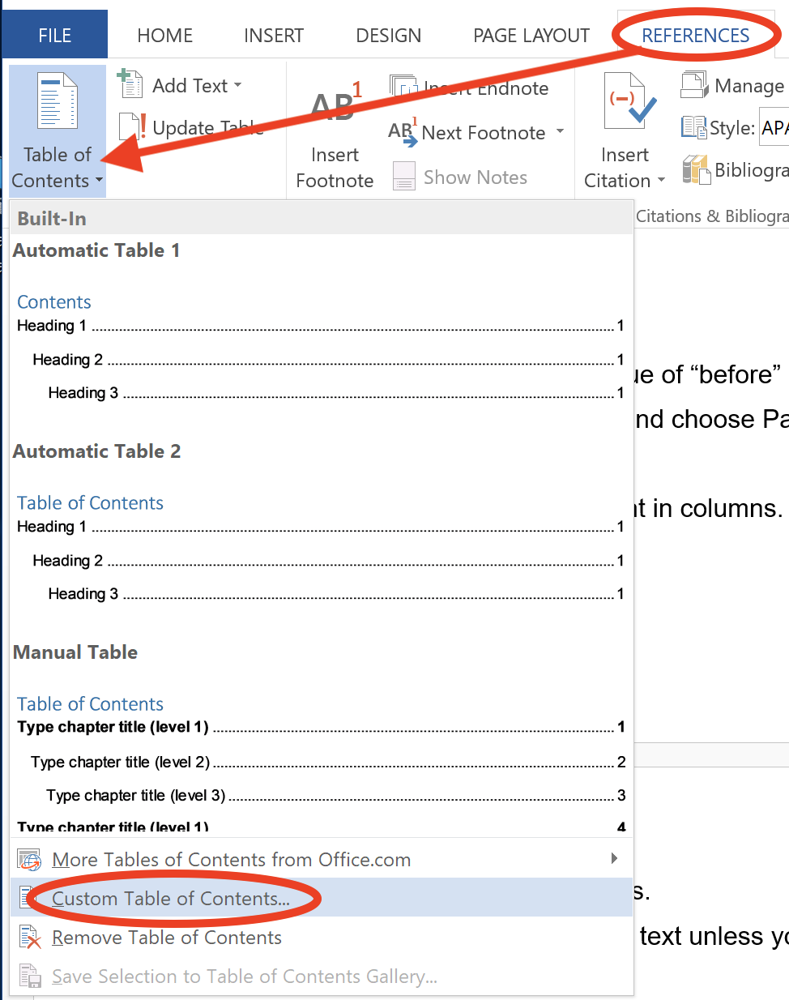

How to achieve checklist item #9: Data Tables

Insert a table…
Insert > Table > Insert Table.
Note: Do not select “Draw Table.”
In the Insert Table window, enter the number of rows and columns for the table, then select OK (See Figure 9).

Figure 9
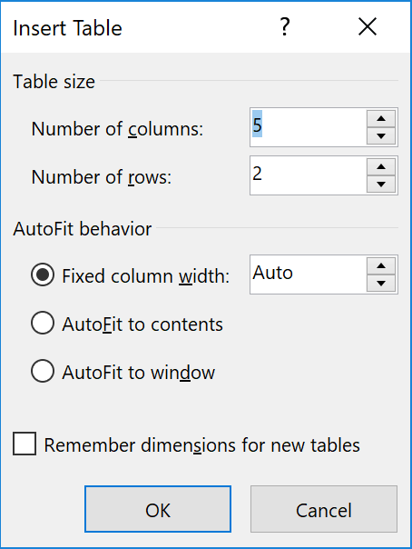
Ensure that Rows do not Break Across Pages
Select the entire table by clicking on the arrows in the upper left corner of the table, or go to Table Tools > Layout > Select > Select Table.
“Right-click” and select Table Properties, or select Properties in Table Tools > Layout.
In the Table Properties window, select the “Row” tab.
Uncheck “Allow row to break across pages.”
Select OK and close Table Properties window.

Set the Header Row to Repeat Across Pages
Select the top row in the table.
“Right-click” > Table Properties.
Check “Repeat as header row at the top of each page.”

Give the Table a Name (Caption)
References > Insert Caption, or
Select Table > right-click > Insert Caption.
Enter the name of the table in the caption field.
Choose “Above selected item” as the position.
Note: The caption text may be italicized by default. You can format this text as desired using the formatting tools in the Home tab.

Add Gridlines
“Right-click” on the table and choose “Select Table.”
Or
Table Tools > Layout > Select Table.
Then select: Table Tools > Design > Borders > All Borders.
Avoid merging cells or leaving cells blank.
Note: Alternative Text can be used for complex tables and/or tables with an unusual structure.

How to achieve checklist item #10: Hyperlinks

Make Text a Hyperlink
Select the text that will become a link.
Press Control + K, or go to Insert > Hyperlink.
Paste or enter the URL in the “Address” field. Select OK.
Figure 10
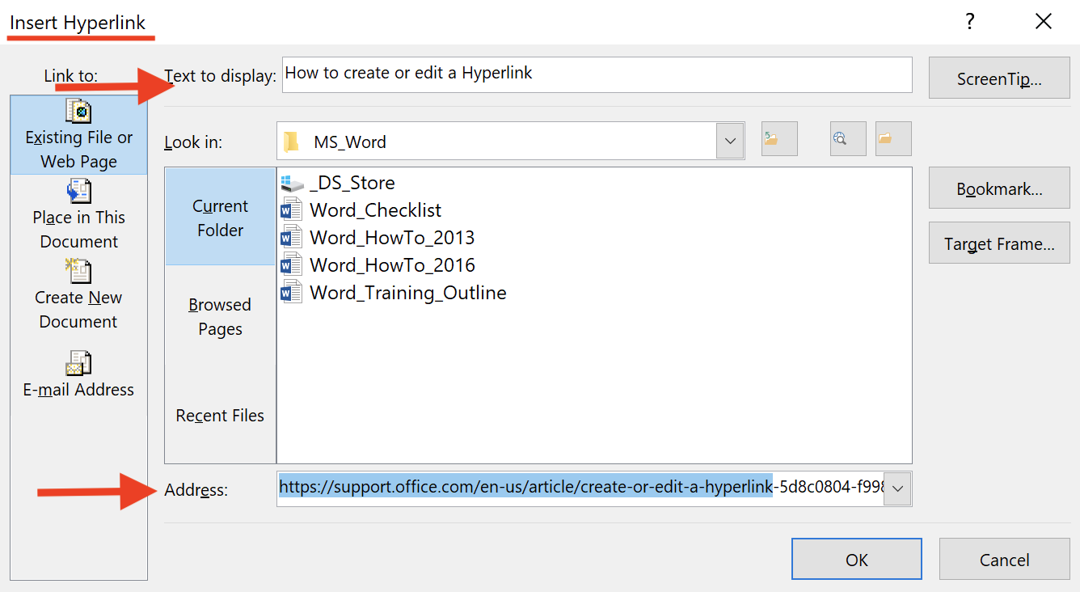

Create Unique Display Text for a URL
Place the cursor before the URL using the arrow keys.
Press Control + K, or select Insert > Hyperlink.
Enter text in the “Text to Display” field (See Figure 10). Select OK.
Note: You can also “Right-click” on the text and choose “Hyperlink” from the menu.

How to achieve checklist item #11: Lists

Create a Bulleted List
Position the cursor where you want to insert the bullet list.
Home > Bullet, or CTL + Shift + L.
Type any text and press enter to start the next bullet.
To end the bullet list, press enter twice.
Figure 11
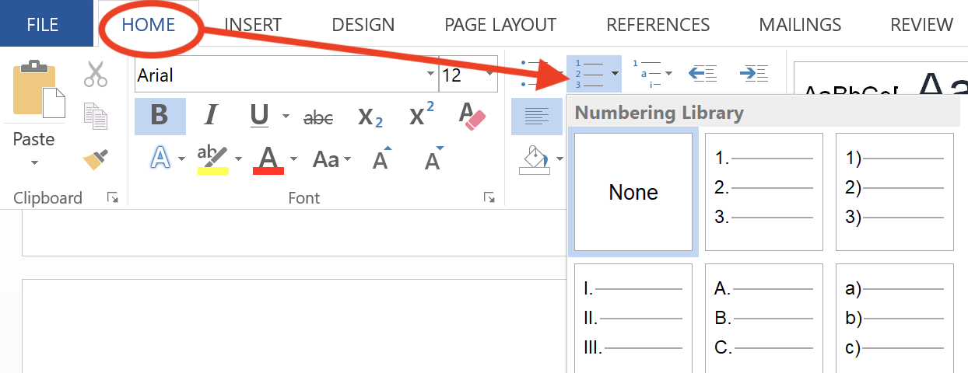

Create a Numbered List
Position the cursor where you want to insert the number list.
Home > Numbering (See Figure 11).
If successful, you should have a number one. Type any text and press enter to start the next list item. To end the list, press enter twice.
Note: You can also enter the text you want to appear as a list first. Begin each list item on a new line. Then, select the text and go to Home > Bullet or Numbering.

How to achieve checklist item #12: Images

Add Alternative Text to an Image
Select the Image. (Handles should appear around the image).
“Right-click” on the image and select Format Picture.
Layout and Properties > Alt Text
In the “Description” field, enter concise, meaningful alternative text for the image.
Leave the Title field blank (See Figure 12).
Figure 12
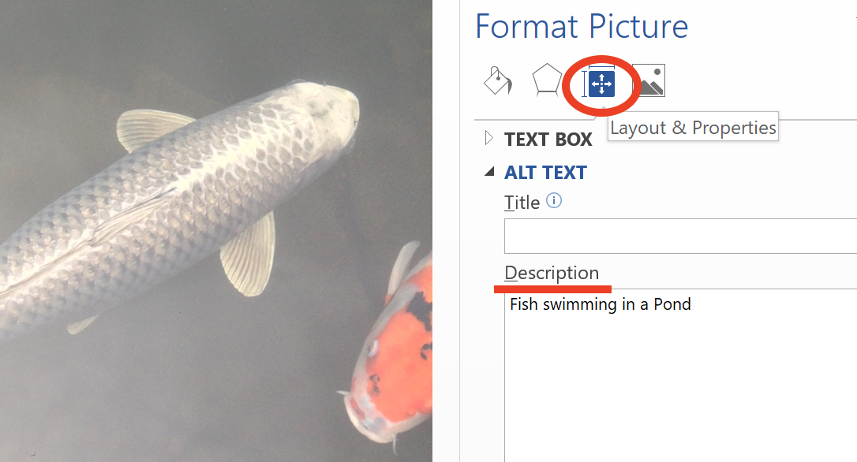

Position your Image
Picture tools > Wrap Text > In-Line with Text.
Or
Right-click on the image.
Wrap Text > In-Line with Text.

Give your Image a Name (Caption)
Select the image.
“Right-click” on the image.
Select Insert Caption.
Enter text to name your figure.
Choose “Above the Selected Item” for Position.

How to achieve checklist item #13: Charts & Graphs

Insert a Chart
Insert > Chart.
Choose your chart type.
Edit your chart data.
When your chart is selected, the “Chart Tools” tab will appear.

Customize Chart Data Labels
Figure 13
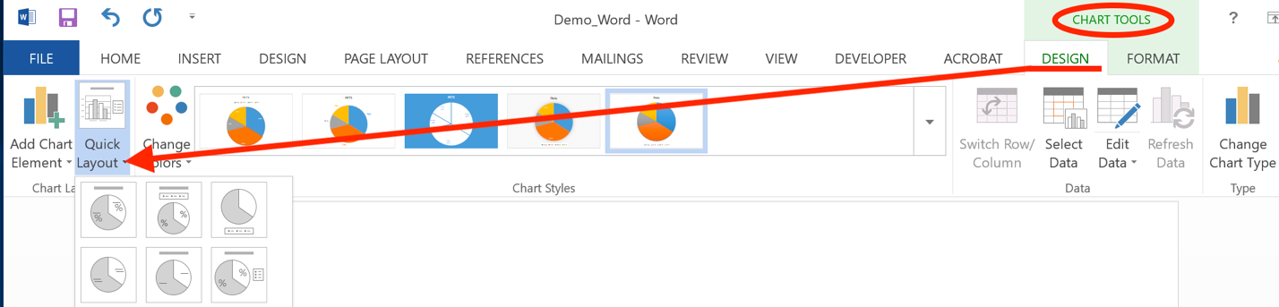Chart Tools > Design > Quick Layout (See Figure 13).
Choose a layout that positions labels inside or adjacent to pie slices.
Or
Chart Tools > Layout.
In the “Current Selection” area of the ribbon, select “Data Labels” from the dropdown.
Select “Format Selection”.
Ensure that “Value” and “Category” are selected.
Select a position that places labels adjacent to or inside pie slices.

Give your Chart a Name (Caption)
Select the chart.
“Right-click” on the chart.
Select “Insert Caption”.
Enter text after the “Figure” label.
Note: The chart title which lies inside the chart area will not be read by screen readers.

Provide Alternative Text to your Chart:
Select the chart.
“Right-Click” on the chart.
Select “Format Chart Area”.
Select “Alt Text”.
Describe the chart in the “Description field”. For simple charts, include the chart data and labels separated by commas.
For charts and graphs with complex data, display data in an adjacent table or include a text description within the document. The alt text can then be used to direct users to this information. Avoid using location-based language such as “to the right”.

Position your Chart In-Line with Text
Select the chart.
“Right-click” on the chart.
Hover on “Wrap Text” then choose “In-Line with Text”.
Or
Chart Tools > Format > Wrap Text > In-Line with Text.
Note: Remember that color-alone cannot be the only means of conveying information. Avoid using chart and graph styles that rely solely on color. Use labels and/or pattern fills so that a secondary visual characteristic is present.
“Right-click” the Data Point or Series. Select the “Fill” icon that appears in the “Format Data Point (or Series) section, and choose the Pattern fill, Radio Button. Choose a Pattern that is distinguishable from neighboring chart items (See Figure 14).

Figure 14
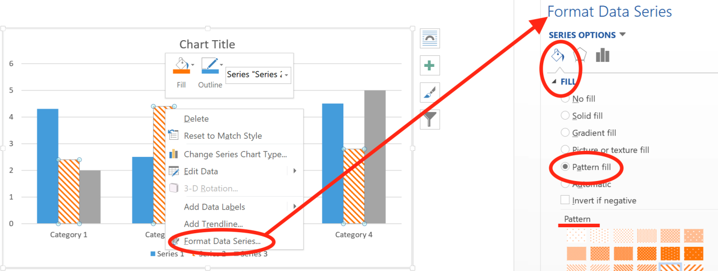

How to achieve checklist item #14: Forms
*Note: It is strongly recommended to create accessible electronic forms in HTML or PDF format. If Word must be used to create an electronic form, use the following guidelines. Screen reader users, please visit Creating Accessible Forms in MS Word by Freedom Scientific for keyboard commands.

Creating Electronic Forms in Word
- Enable the Developer Ribbon: File > Options > Custom Ribbon. In the “Main Tab” window, check “Developer”. Select OK.
- Provide Instructions: At the top of your form, include the form name (make this a heading 1) and any pertinent instructions that tells users how to complete the form. Indicate which fields are required.
- Create a section break: Layout > Breaks > Continuous.
- Begin Creating your form: Type the form element label; for text boxes and dropdowns (also called select elements), the labels should precede the form element. For checkboxes and radio buttons, the labels should appear after the form element.
- Insert Legacy Form Element: Go to the Developer tab and choose the “Legacy Tools” icon in the Controls section of the ribbon. Select a form element from the Legacy Tools menu (See Figure 15).

Figure 15
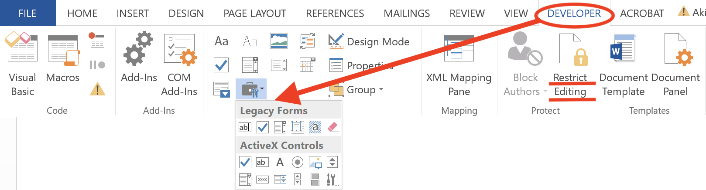
- Set form element properties: Right-click on the form element in your document and choose “Properties” In the dialogue box, enter a name for this form element in the Bookmark field. No spaces may be used in this field. Example: FirstName.
- Add Help Text: Select “Add Help Text in the bottom of the properties menu. Check the “Type your own” radio button and enter the label for this form element. Important: This label should match the text label that is visible in your document. If the form element is a checkbox, also enter the question and the label (e.g. “Rate this event, Good”. Select OK for the Help Text and Properties dialogue boxes.
- Protect your form: You must protect the section of the form that contains the form elements in order for screen reader users to navigate to the form controls and for dropdown form elements to work properly. Go to Developer > Restrict Editing. In “2. Editing Restrictions”, check “Allow only this type of editing in the document”. Select “Filling in Forms” in the dropdown. Then, select the “Select Sections” link. Check the section of the document in which the form appears and leave other sections unchecked. Select OK.
Note: The text in the section of the document that is protected will not be editable and will not be read aloud by screen readers. Screen readers will access the Help Text when for each form element. This is why Help Text is required for each form element.

Creating Printable Forms:
If you are creating a printable form, follow these guidelines:
- Use a text label followed by a colon.
- Do not use underscores to create blank lines.
- Do not use layout tables with merged and blank cells to create forms.
- Use columns to layout form content and be conscious of reading order.

How to achieve checklist item #15: Check
File > Info < check for Issues > Check Accessibility (See Figure 16).
Accessibility Checker results will appear in a panel on the right side of the document.
Correct all issues.

Figure 16
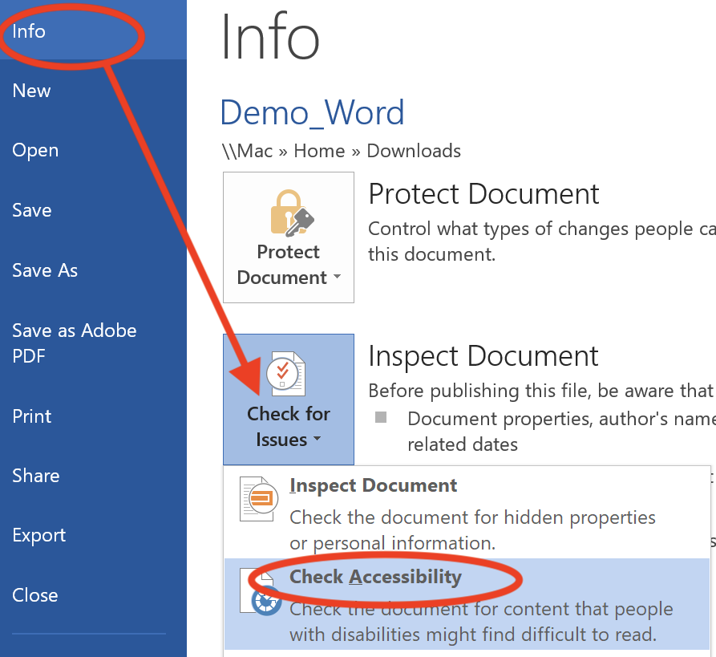

How to achieve checklist item #16: Convert to PDF

How to Convert MS Word to PDF Using “Save as”
- Begin by creating an accessible Word document. (Refer to the “Creating Accessible Documents in Microsoft Word 2010” handout).
- File > Save as.
- In the “Save as” dialogue box, select “PDF” from the “Save as Type” dropdown (See Figure 17).
- Select “Options”.
- Check the following:
- Create bookmarks using headings
- Document Properties
- Document Structure Tags for Accessibility.
- Select OK.
- Enter a concise, meaningful filename that is free of spaces, special characters, and unfamiliar abbreviations.
Figure 17
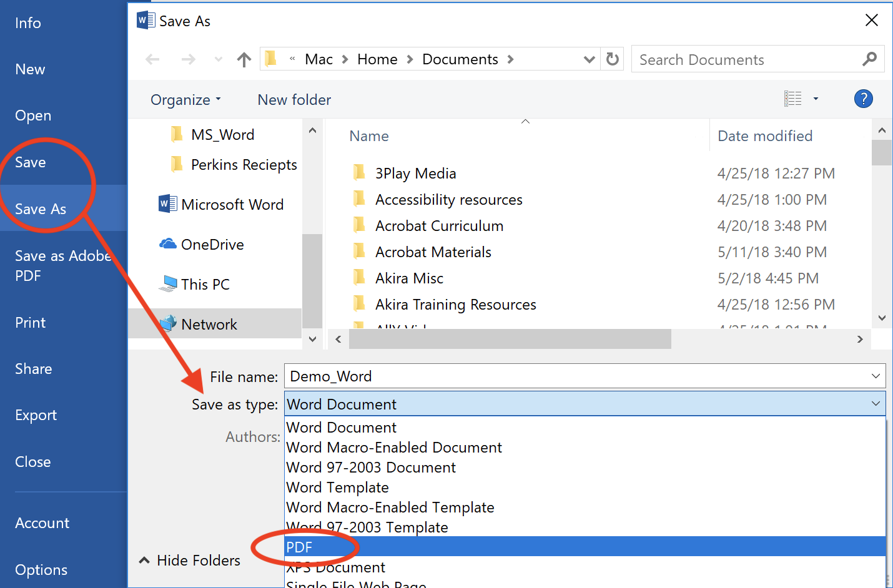

How to Convert MS Word to PDF Using Acrobat Plug-In
Note: If Adobe Pro is installed on your computer, then an Adobe tab will be visible in MS Word. If you do not see the Acrobat tab, then Adobe Pro is not installed on your computer and you would not use this method for converting your Word document. (Adobe Reader is not the same application as Adobe Pro).
- Begin by creating an accessible Word document. (Refer to the “Creating Accessible Documents in Microsoft Word 2010” handout).
- Acrobat > Preferences.
- In the Settings tab, check the following:
- Create bookmarks
- Add Links
- Enable Accessibility and Reflow with tagged Adobe PDF
- Enable advanced tagging (See Figure 18).
Figure 18
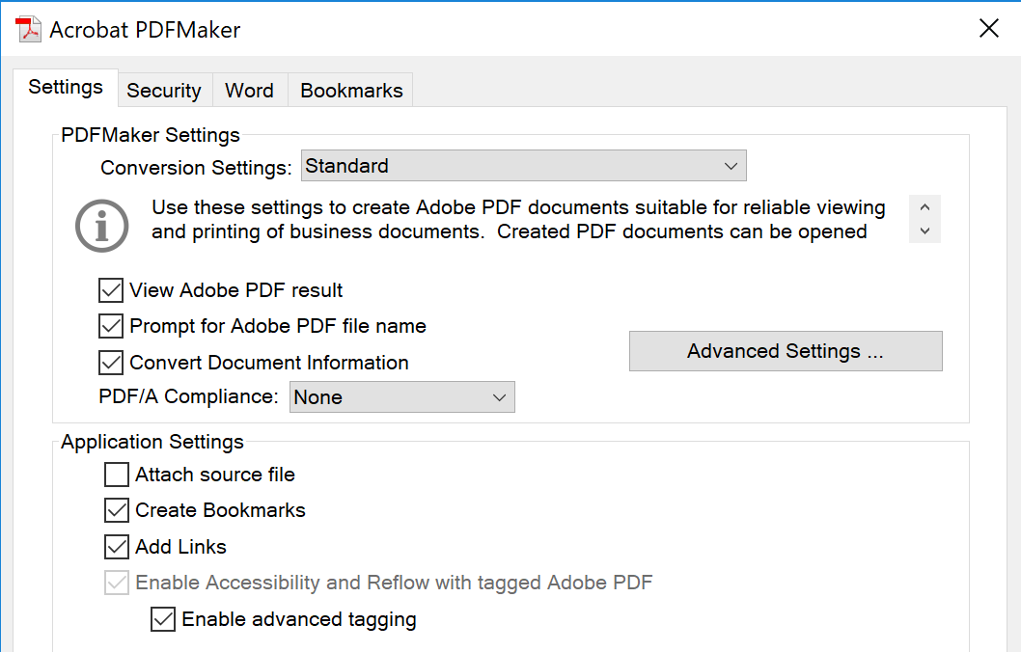
- In the Word tab, check the following:
- Convert footnote and endnote links
- In the Bookmarks tab, check the following:
- Convert word headings to bookmarks.
- Acrobat > Create PDF.
- Enter a concise, meaningful filename that is free of spaces, special characters, and unfamiliar abbreviations.
Note: If “View Result” is checked in the Save As dialogue box, the PDF will automatically open in Adobe Reader or other default PDF application.
Notice: Following these guidelines does not guarantee your PDF meets all accessibility requirements. Specific tags, such as table headers, will be lost during Word to PDF conversion. Check and remediate your document in Adobe Acrobat Pro DC.

