Assigning Language to Portions of Text in Microsoft PowerPoint

Step 1:
Highlight the text that it in a specific language. In your ribbon go to Review > Language > Set Proofing Language

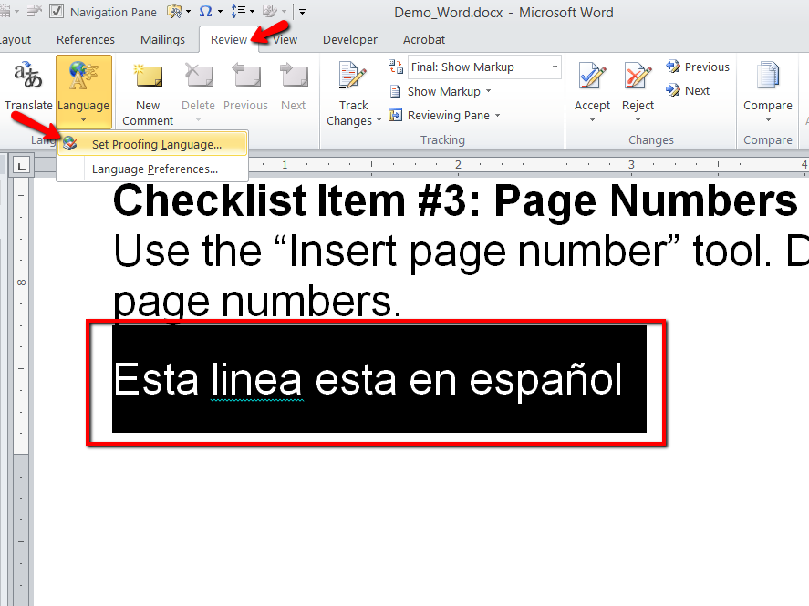

Step 2:
In the language pop-up window, Select the desired language.
Note: There is also a checkbox option available to "Detect Language Automatically". This can be helpful, but always double check that Word has properly identified the language.
