How to Create Accessible Presentations in Microsoft PowerPoint

How to achieve checklist item #1: Filename

Accessible Filename
File > Save
Or
Control + S
Use a concise, meaningful filename that is free of spaces, unfamiliar abbreviations, and special characters. (Underscores and hyphens are okay).
Examples of accessible filenames:
- Accessible_Documents_2010
- USADA_Guidelines
- 2016_Benefits_Package
Examples of inaccessible filenames:
- My Presentation1.pptx
- PEP Program.pptx
- Mary’s DTS@work.pptx
- My Presentation About the Challenges of Accessing Digital Information in the Workplace and at School.pptx

How to achieve checklist item #2: File Properties
File > Info
On the right is the Properties pane.
Enter Author and Title information for the document in the appropriate fields. (See Figure 1)
Figure 1
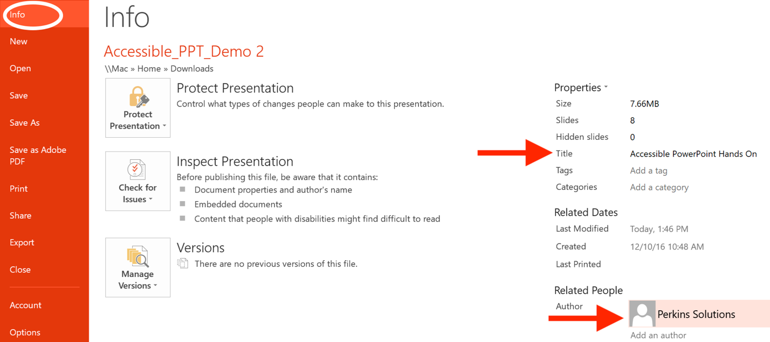

How to achieve checklist item #3: Text
Home > Font
Note that specific fonts are associated with templates and themes, but can be changed (See Figure 2).
Avoid using scripts (handwriting) and condensed fonts.
Figure 2
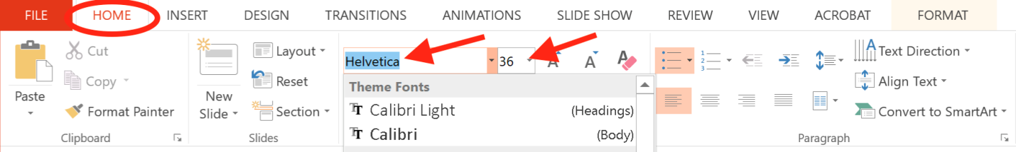

How to achieve checklist item #4: Theme & Background
Design > Themes
Or
Design > Format Background (See Figure 3).
Choose a theme or style that preserves contrast between objects and does not make text harder to see.
Figure 3
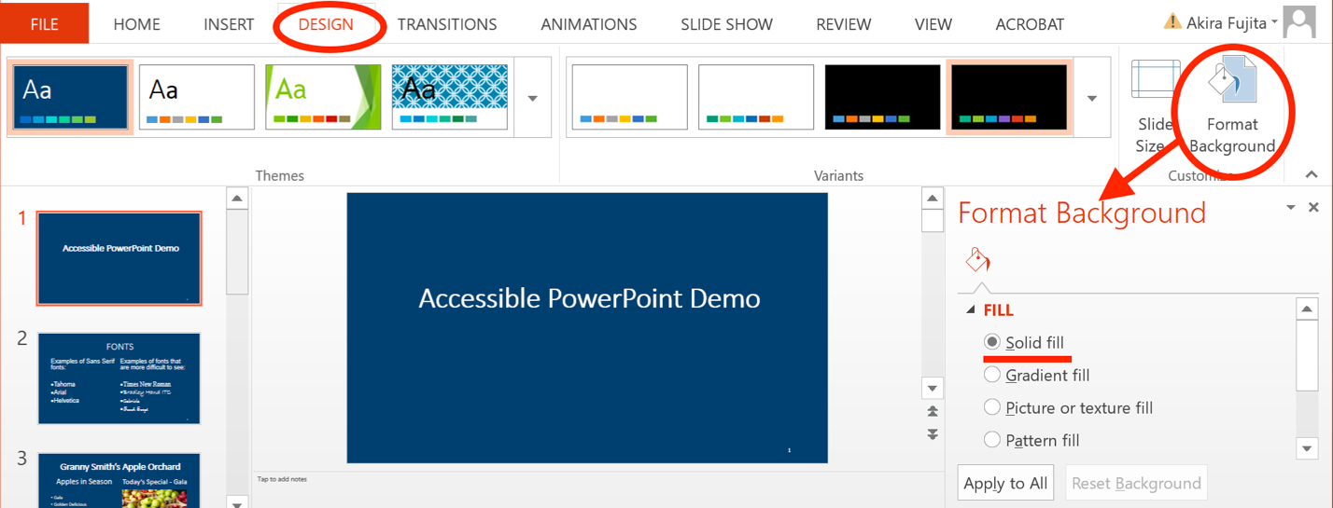

How to achieve checklist item #5: Color
If text-background combinations appear to have poor contrast, use the Colour Contrast Analyzer to test if contrast ratio is sufficient. Change font color or background color as needed to increase contrast (See Figure 4).
Figure 4
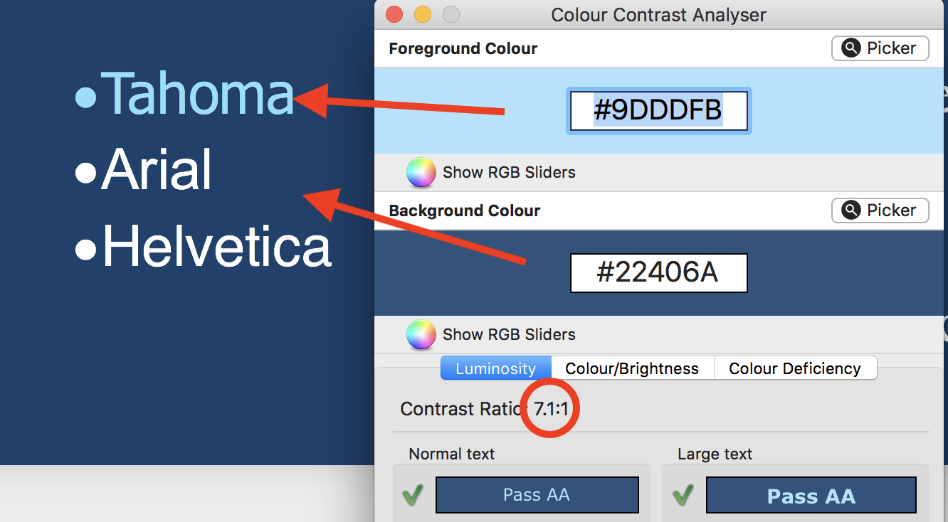
Avoid using backgrounds that contain images or patterns and compromises text-background contrast.
Use font colors that have a color contrast ratio (text to background) of 4.5:1 for 14 point font and smaller, and 3:1 for 14-point bold font or larger.
When color is used to convey meaning or distinguish elements, a secondary characteristic must also be used.

How to achieve checklist item #6: Slide Title
Home > New Slide.
Or
Home > Layout.
Or
“Right-Click” on the slide and select “Layout.”
Choose a slide layout that includes a Title placeholder.
Slide Titles can also be viewed or modified using the “Outline View” by selecting the “Outline View” button in the Presentation Views section of the “View” tab (See Figure 5).
Figure 5
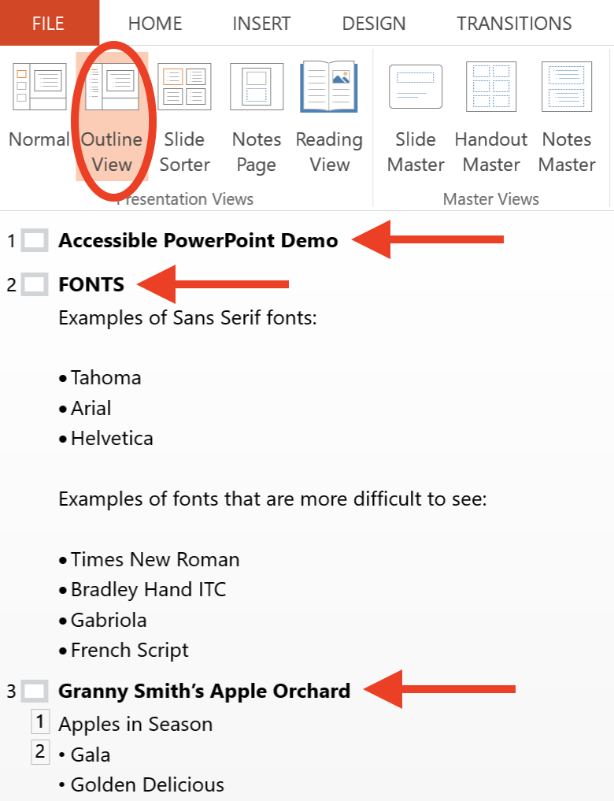

How to achieve checklist item #7: Slide Numbers
Insert > Header and Footer.
Check “slide number” in the Header and Footer Window (See Figure 6).
Figure 6
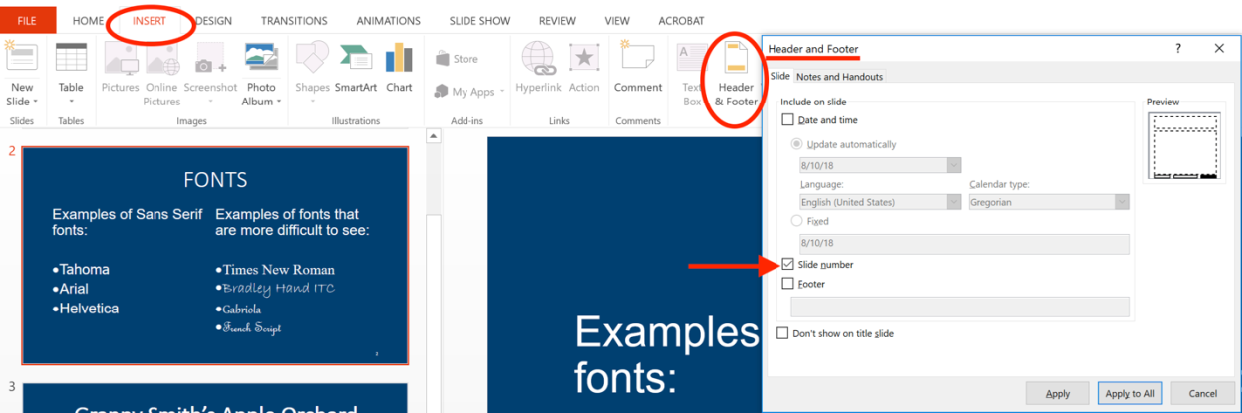

How to achieve checklist item #8: Hyperlinks

Create a Link from Text
Select the text you want to become a link.
Insert > Hyperlink Or “Right-Click” and choose “Hyperlink…”
Enter or paste the URL into the “Address” field. Select OK.

Add Unique Display Text to a URL
Insert > Hyperlink Or “Right-Click” and choose “Hyperlink…”
Enter unique display text in the “Text to display” field. Select OK (See Figure 7).
Figure 7
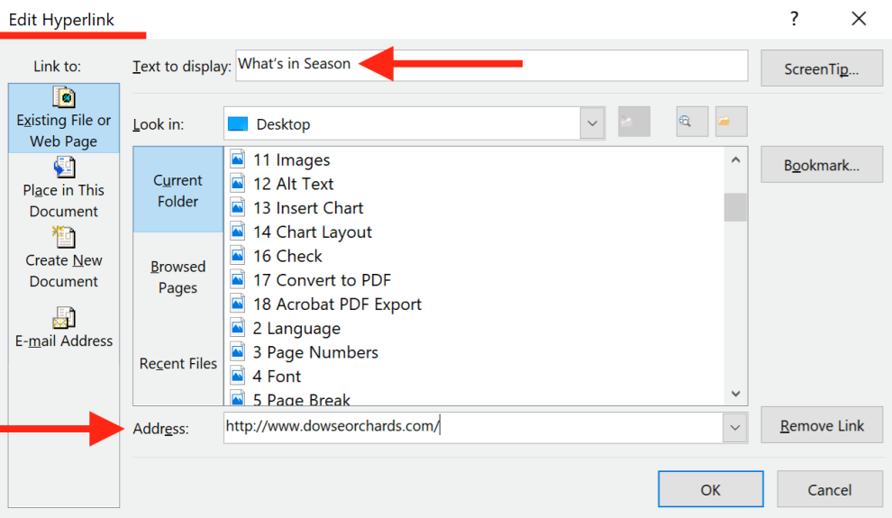

How to achieve checklist item #9: Reading Order
Select the object that you want to receive focus first.
Drawing Tools > Arrange > Bring to Front
Repeat this process for each object.

Test the Reading Order
Click off the slide once.
Press the tab key and observe the reading order of the objects on the slide.
The “Selection” pane can also be used to view the position of and reorder objects.
Home > Arrange > Selection Pane…
Figure 8
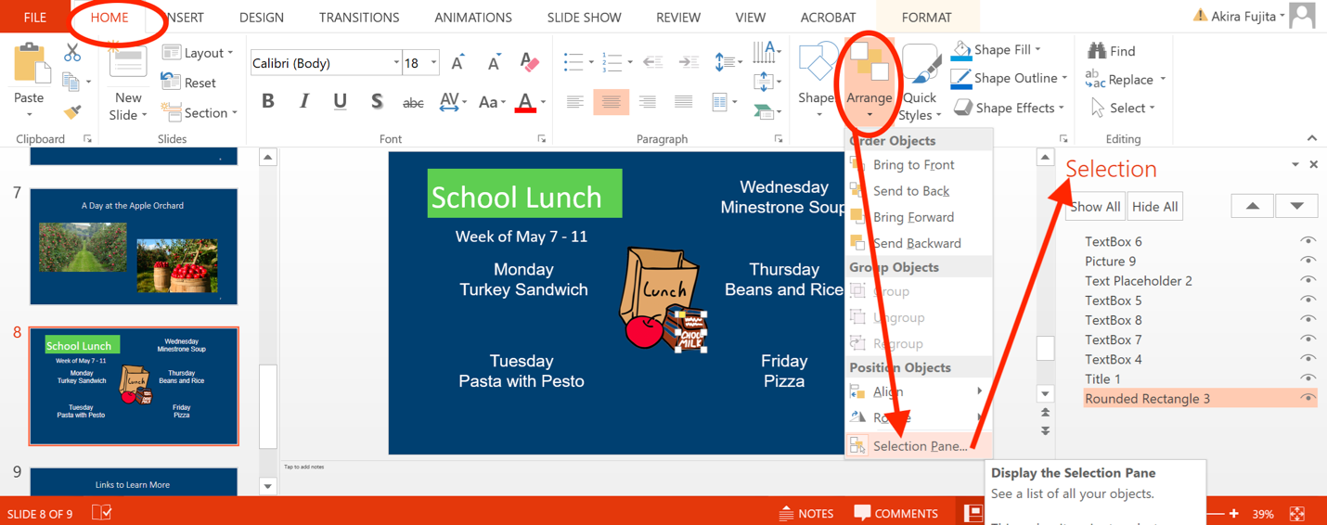
Select the “arrange” Menu in the Home tab, and choose “Selection Pane” (See Figure 8).
Note: The first Object should be at the very bottom and the last object should appear at the top of the list, in the “Selection Pane”.

How to achieve checklist item #10: Images

Insert an Image
Make sure you have an image placeholder on your slide.
Select the icon in the placeholder.
Browse and select the picture you want to insert.

Add Alt Text to your Image
With the image selected, “right-click” on the image and choose “Format Picture.”
Select Alt Text in the Format Picture window.
Enter concise, meaningful alt text in the “Description” field.
Leave the “Title” field blank (See Figure 9).
Figure 9
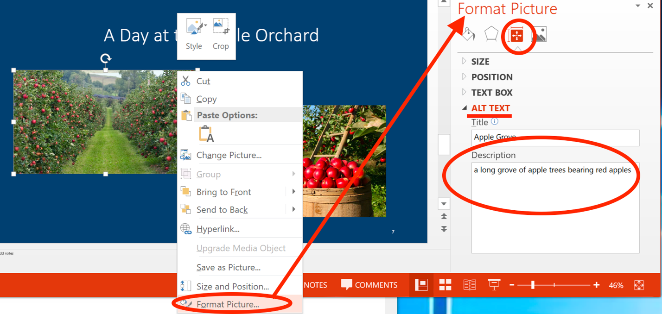

How to achieve checklist item #11: Tables

Insert a table
Insert > Insert Table
Or
Select the table icon in a content placeholder.
Do not use “Draw Table”.
Choose a table style in Table Tools > Design.
Note: Ensure that the style you choose will maintain sufficient contrast between text and cell background.

Add a Header Row
Table Tools > Design.
Make sure “Header Row” is checked.

Add Gridlines
“Right-click” on the table and choose “Select Table.”
Or
Table Tools > Layout > Select Table.
Table Tools > Design > Border Icon > All Borders.
Note: Avoid merging cells or leaving cells blank.
Figure 10
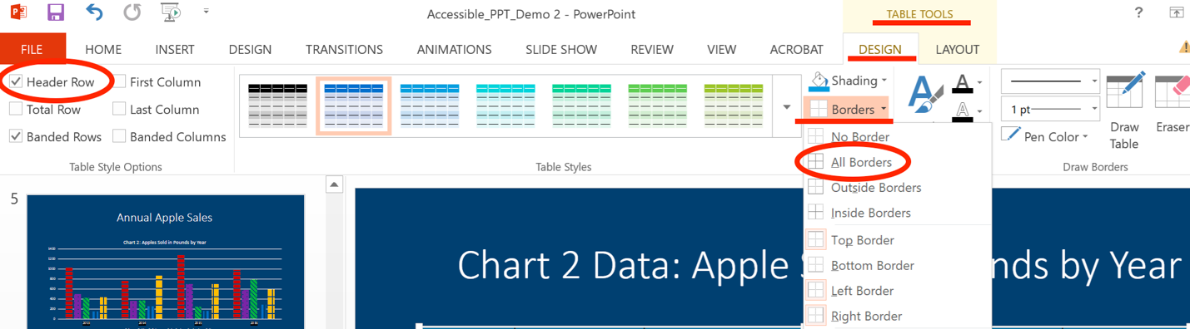
Note: Alternative Text can be used for complex tables and/or tables with an unusual structure.

How to achieve checklist item #12: Lists
Home > Paragraph section > Bulleted List or Numbered List.
Note: Typical text placeholders will default to list style. To remove bullets, select text, then select “None” from the Bulleted List icon.
Figure 11
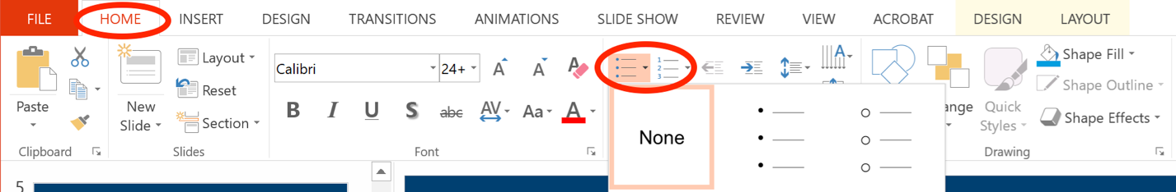

How to achieve checklist item #13: Charts & Graphs

Add Alt Text to a Chart or Graph
Option 1:
“Right-click” on the chart and select “Format Chart Area”.
Or tab to chart and press Shift + F10.
Add a description of the chart in the “Description” field.
Leave the “Title” field blank.
Option 2:
Add the alt text, “Full description can be found in the Notes section of this slide.”
Enter a description of the chart or graph in the Notes section.
Warning: If converting to PDF, notes content will not be accessible. This technique should only be used if format remains PPT. Otherwise, a text alternative will need to be provided in a subsequent slide or adjacent text box.
Note: Remember, a pie chart with a legend is using color alone to convey meaning. You will need to customize pie chart labels.
Figure 12
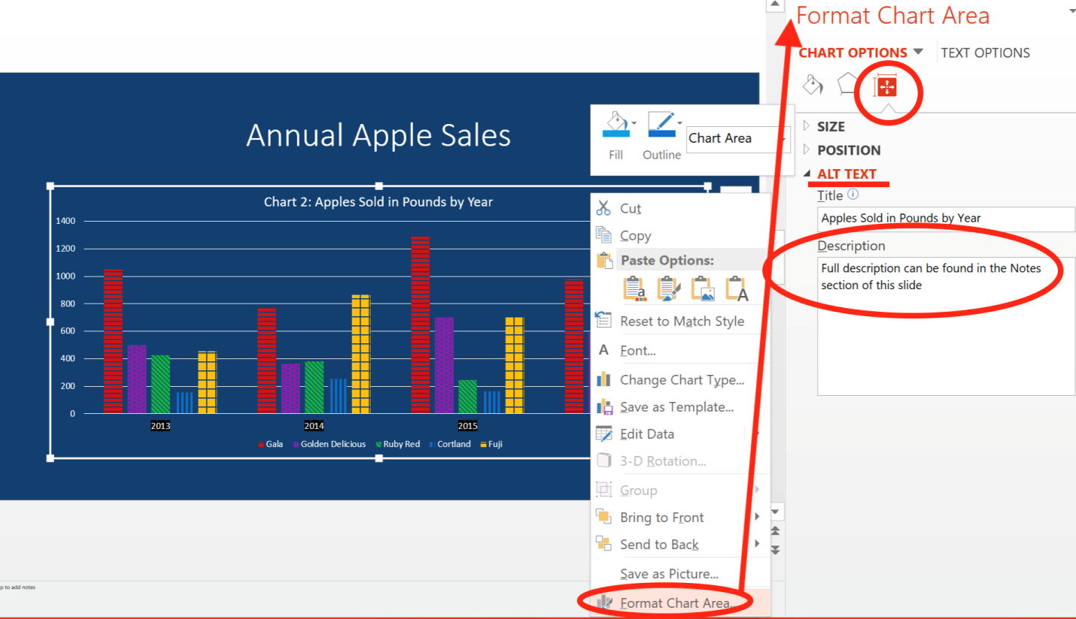

Customize Data Labels in a Pie Chart
Chart Tools > Design > Quick Layout.
Choose layout that positions labels and data inside or adjacent to pie slices.
Note: You can choose an inside or outside position as long as the user can determine which label corresponds with which “slice” of the pie chart.
Note: Remember that color-alone cannot be the only means of conveying information. Avoid using chart and graph styles that rely solely on color. Use labels and/or pattern fills so that a secondary visual characteristic is present.
To add a pattern fill to a chart, “Right-click” the Data Point or Series. Select the “Fill” icon that appears in the “Format Data Point (or Series) section, and choose the Pattern fill, Radio Button. Choose a Pattern that is distinguishable from neighboring chart items (See Figure 10).
Figure 13
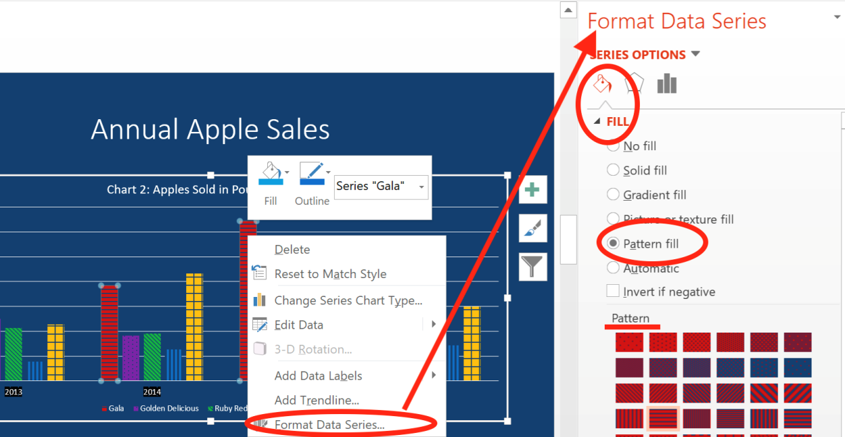

How to achieve checklist item #14: Check
File > Info > Check for Issues > Check Accessibility.
Correct all found errors.
Figure 14
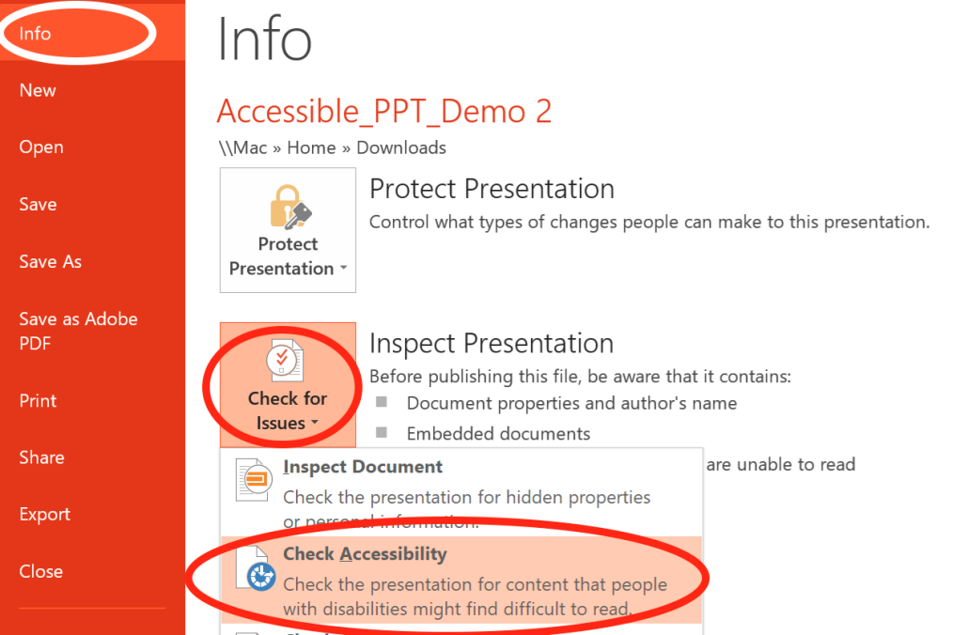

How to achieve checklist item #15: Convert to PDF
Convert to PDF using “Save as”
File > Save as.
Select destination.
Enter filename.
Select PDF from the “Save as type”.
Select Options.
Make sure the following are checked:
Document properties.
Document structure tags for accessibility.
Select OK.
Or
File > Export > Create PDF/XPS.
Select “Options” and follow instructions as provided above.
Select Publish.
Figure 15
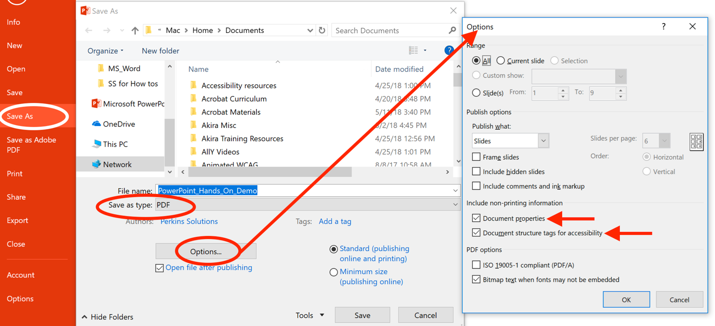
Note: Following these guidelines does not guarantee your PDF meets all accessibility requirements. Check your PDF in Adobe Acrobat pro DC and remediate any found issues.

