How to Create Accessible Email Messages in Microsoft Outlook

How to achieve checklist item #1: Format
New Email > Format Text > HTML.
Or
To set as default:
File > Options > Mail > Compose message in this format: HTML (See Figure 1).
Figure 1
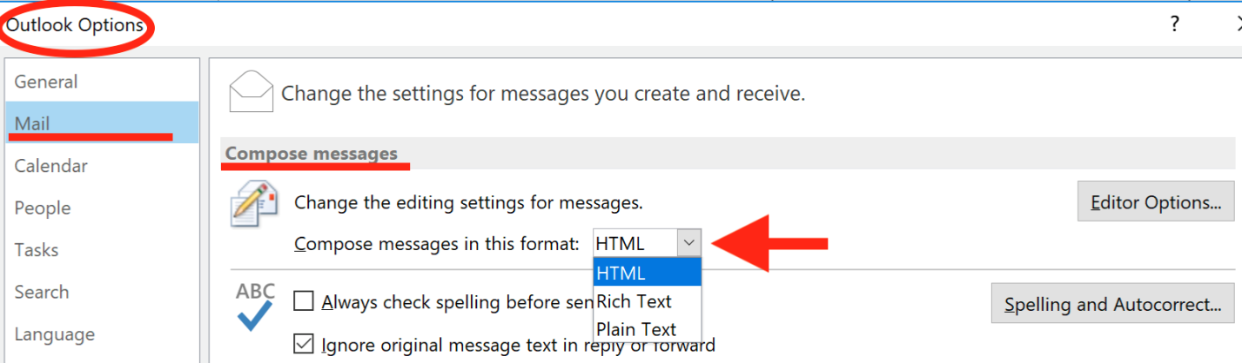

How to achieve checklist item #2: Subject
Examples of appropriate subjects:
- Monday Meeting
- English Exam
- Tuesday’s Agenda
Examples of less accessible subjects:
- PEP on Friday
- What time are you going to lunch?
- KL doc need 2 sign

How to achieve checklist item #3: Text

Set Font for New Message
New Email > Messages (or Format Text).

Set Font Preferences for All Messages
File > Options > Mail > Stationary and Fonts.
Select “Font” for “New Mail Messages” and for “Replying and forwarding messages” and make your selections for typeface, color, and size (See Figure 2).
Figure 2
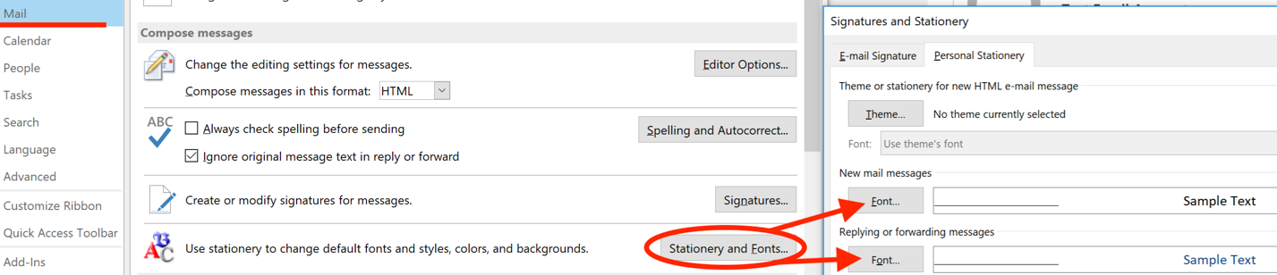

How to achieve checklist item #4: Color
File > Options > Mail > Stationary and Fonts.
Select “Theme”.
Be sure to choose a dark font color that contrasts well against a white background.
Avoid using background stationary that contains images or patterns and compromises text-background contrast (See Figure 3).
Use font colors that have a color contrast ratio (text to background) of 4.5:1 for 14 point font and smaller, and 3:1 for 14-point bold font or larger.
When color is used to convey meaning or distinguish elements, a secondary characteristic must also be used.

Figure 3
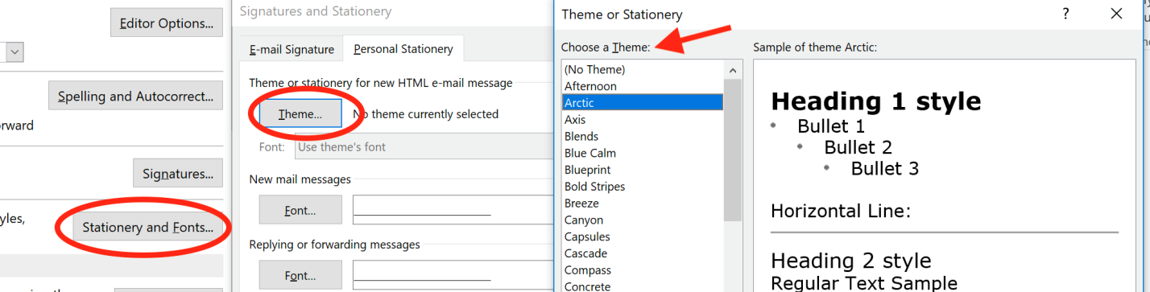

How to achieve checklist item #5: Heading Structure
New Email > Format Text > Styles (See Figure 4).
Note: Select text or place cursor in the paragraph of the email message before choosing Styles (Heading 1, Heading 2, etc...)
Figure 4
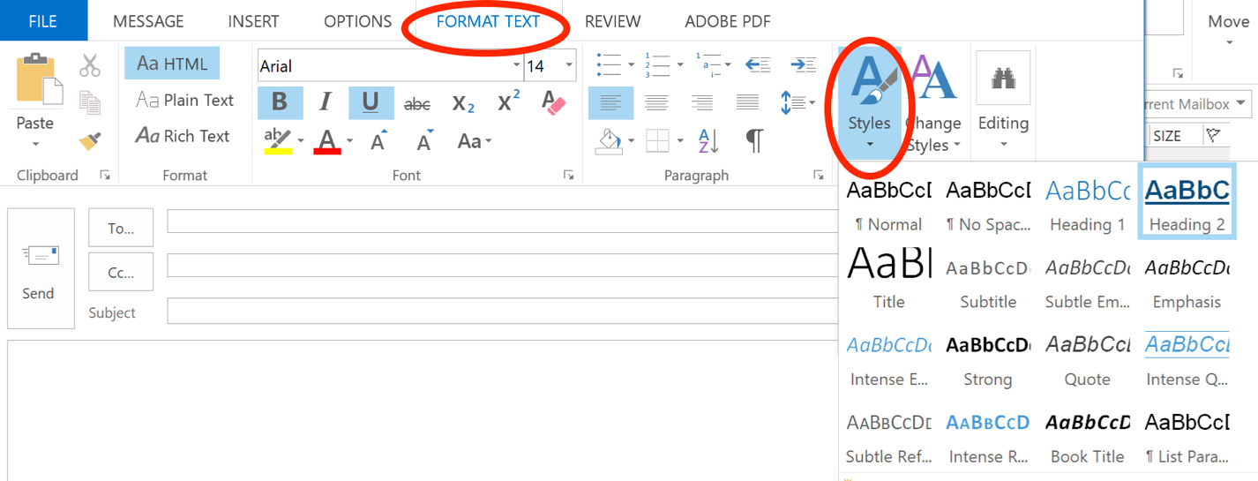

How to achieve checklist item #6: Hyperlinks

Create a Link from Text
Select the text you want to become a link.
Insert > Hyperlink Or “Right-Click” and choose “Hyperlink…”
Enter or paste the URL into the “Address” field. Select OK.

Add Unique Display Text to a URL
Insert > Hyperlink Or “Right-Click” and choose “Hyperlink…”
Enter unique display text in the “Text to display” field. Select OK (See Figure 5).
Figure 5
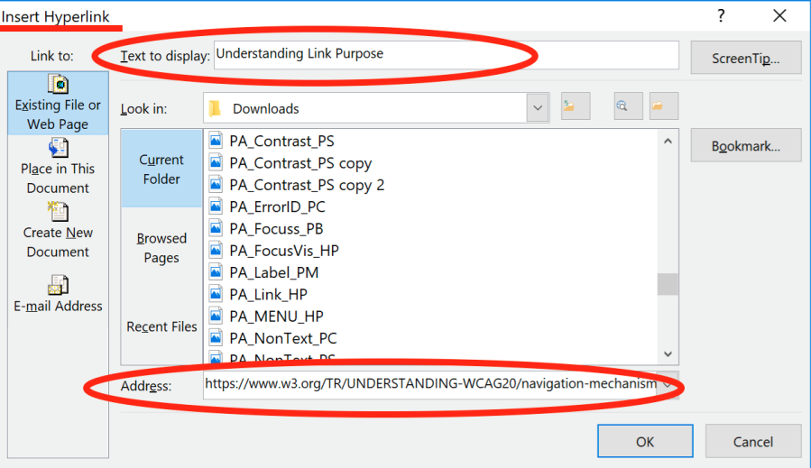

How to achieve checklist item #7: Lists
Select the text you want to become a list.
New Email > FORMAT TEXT OR New Email > Message > Bullets or Numbering (See Figure 6)
Figure 6
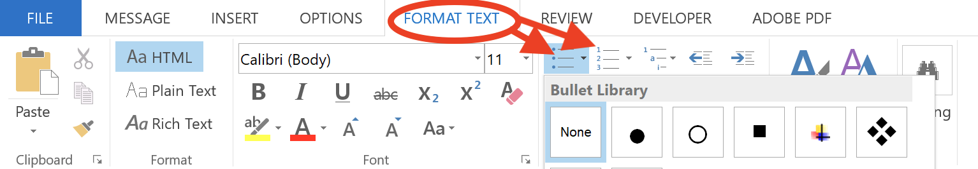

How to achieve checklist item #8: Images

Add Alternative Text
New Email > Insert > Picture.
Choose picture to insert.
Select picture by clicking on it once.
“Right-click” on the picture and choose “Format Picture.”
Select the “Layout & Properties” icon.
Select “Alt text”.
Enter a description of the image in the “Description” field.
Leave the “Title” field blank (See Figure 7).

Position the Picture
“Right-click” on the image and choose Wrap Text > In-Line with Text.
Figure 7
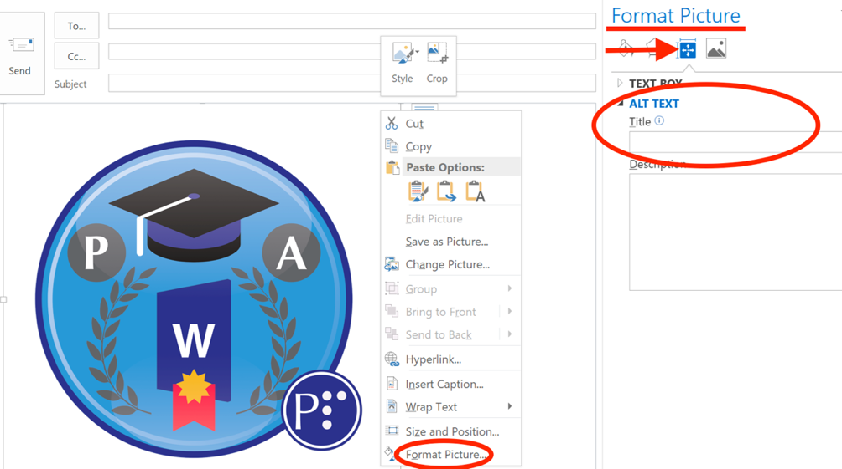

How to achieve checklist item #9: Signature
File > Options > Mail > Signatures.
Select “New” and name the signature you are creating.
Enter your signature in the text box provided (See Figure 8).
Note: If you insert a picture in your signature, such as your business logo, you will not be able to add Alt Text to the image in this location. You must insert an image in MS Word, resize and add alt text, then copy and paste into your signature.
Figure 8
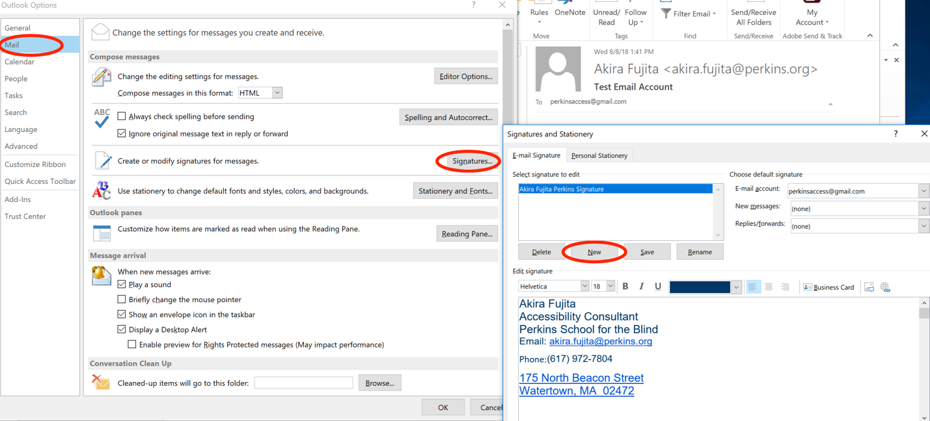

How to achieve checklist item #10: Attachments
Ensure that the documents you attach to your email messages are accessible and are named appropriately.

