How to Create Accessible Google Docs
Note: Documents created by Google Docs may rely on additional authoring software to ensure accessibility for all users.
The controls mentioned in this document may not be accessible using Assistive Technology.
The Accessibility Tab within the Google Docs Menu, includes options for reading/navigating and editing documents by users of Assistive Technology. These options do not provide tools to ensure the accessibility of the documents themselves.
It is recommended to create an Accessible Document Template using options within the Template Gallery for future documents. See: Create a file from a template.

How to achieve checklist item #1: Filename
File > Rename... (See Figure 1)
Enter a filename using the following rules:
- No spaces
- No special character (underscores and hyphens are okay)
- No unfamiliar abbreviations
Accessible filename Examples:
- SmithB_Resume
- 04-12-16_Meeting_Agenda
- US_History_Report_v1

Figure 1
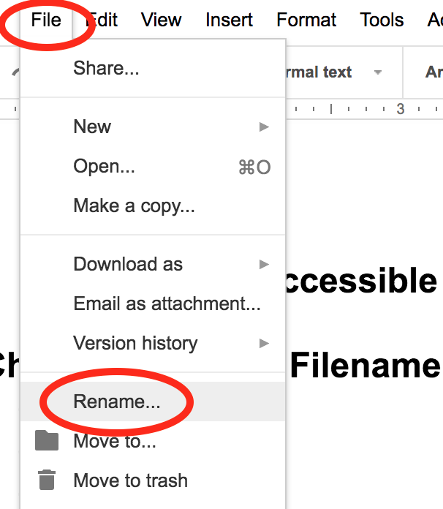

How to achieve checklist item #2: File Properties
Note: Accessible File Properties such as Title and Author cannot be applied successfully in Google Docs.
Export your document and use additional authoring software tools such as Microsoft Word or Adobe Acrobat Pro to ensure accessible File Properties.

Document Language
File > Language (See Figure 2).
Form the Language sub-menu, ensure the correct Language is selected.
Figure 2
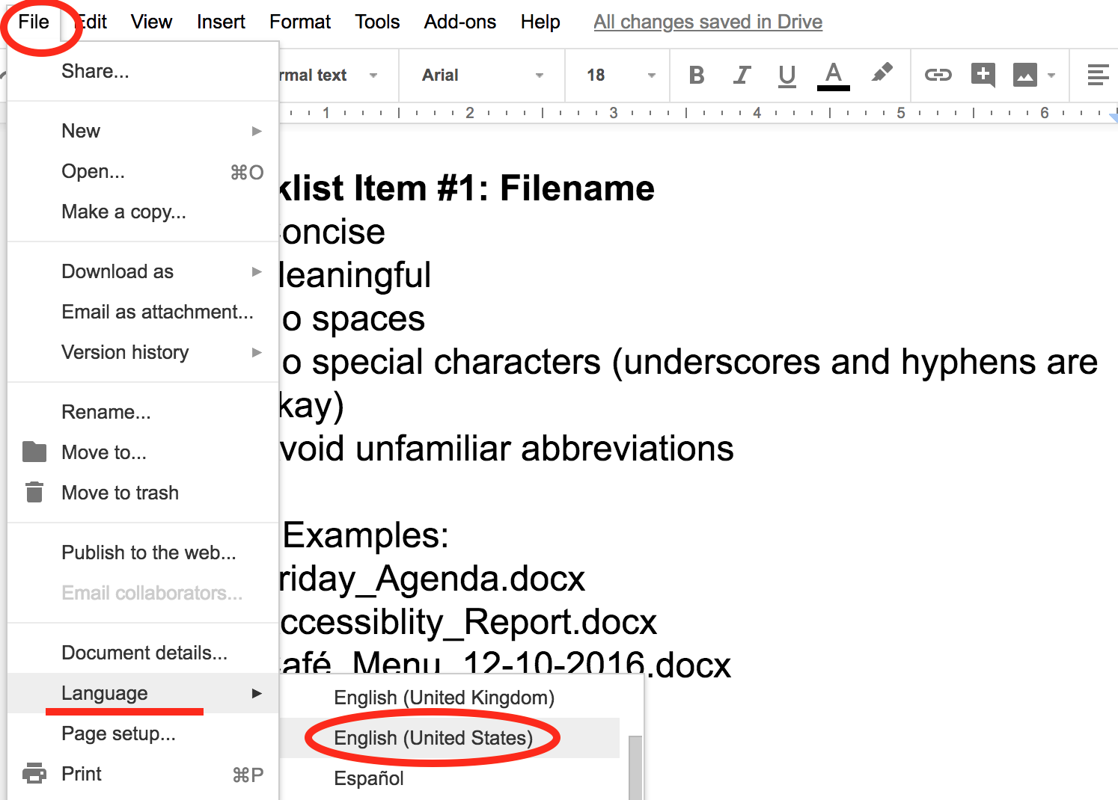

How to achieve checklist item #3: Page Numbers
Insert > Header & page number > Page number
Select from the options, choices include top or bottom right corner placement and omit from first page (See Figure 3).
Figure 3
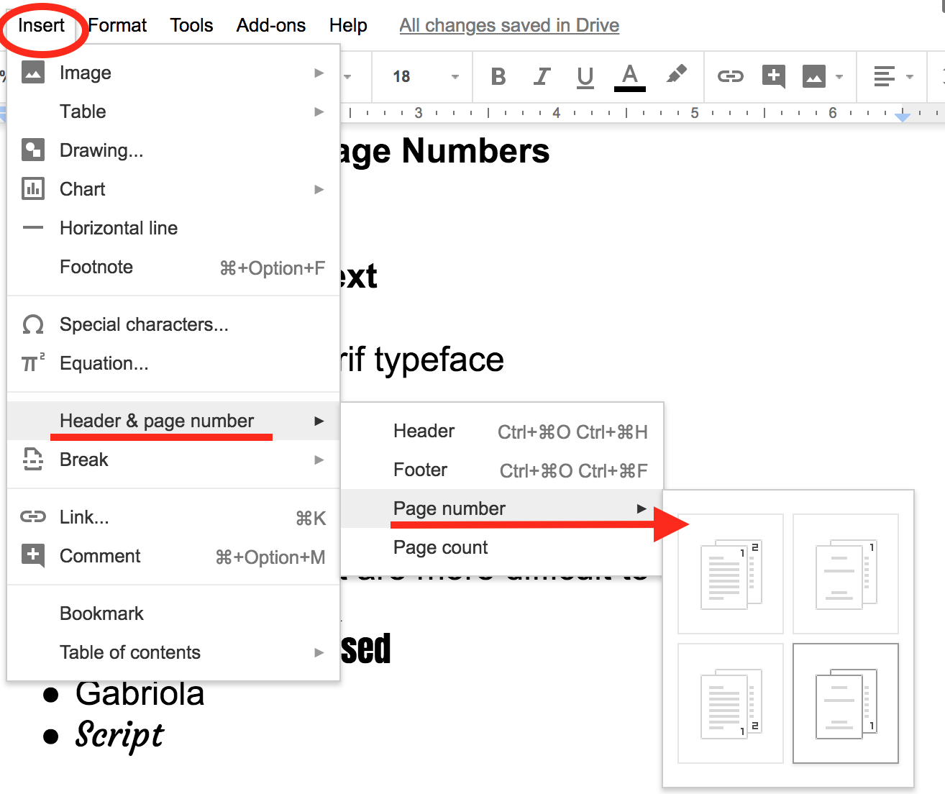

How to achieve checklist item #4: Text

Font
Ensure your cursor focus is on or within text, select the Font drop-down menu item in the Main Toolbar and select a Font (See Figure 4).
Use sans-serif fonts such as Arial, Helvetica, or Tahoma.
Use 12-point font size or larger whenever possible.

Spacing
Use line spacing of 1.0 or greater.
With text highlighted or cursor focus in a text field, select the Line Spacing pop-up button menu item in the Main Toolbar (See Figure 4) if it is not visible, expand your window or select the ellipses …, then Select a line spacing option.
Custom spacing for lines and paragraphs can also be applied by selecting the Custom spacing item from the Line Spacing menu (also see #6 Whitespace).
Figure 4
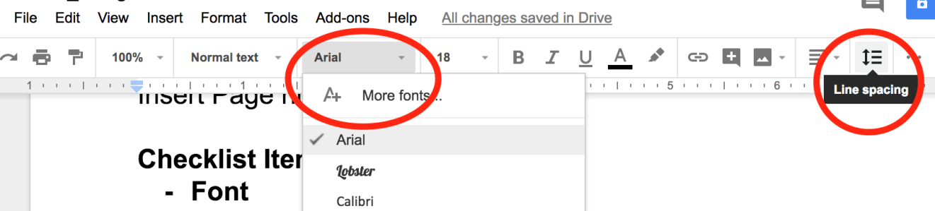

How to achieve checklist item #5: Color
Use a font color that has a color contrast ratio of 4.5:1 for 14-point font or smaller, and 3:1 for 14-point Bold font and larger. Several tools are available to test contrast ratio including the Colour Contrast Analyzer (See Figure 5).

Figure 5
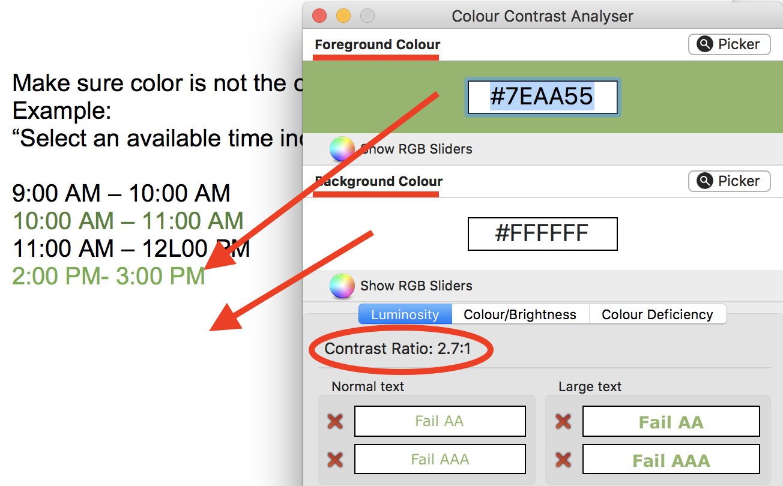
When color is used to convey meaning or distinguish elements, (e.g. highlighted text), an additional font attribute such as an underline, must also be used.

How to achieve checklist item #6: Whitespace
Use formatting tools to create whitespace (e.g. paragraph spacing, page breaks and columns) whenever possible. The Spacebar, Tabs or carriage returns should not be used to create a separation of visual content.

Create Space Between Lines of Text
Select the line of text.
Format > Line spacing (or Line spacing icon) > Add space before (or after) paragraph,
Or choose “Custom spacing…” and type your preferred spacing value(s) (See Figure 6).

Create Columns
Select the text you would like to present in columns.
Format > Columns (See Figure 6).
Select the preferred number of columns. Additional settings such as space between columns can be found by selecting “More options…”.
Note: Be sure to apply only to selected text unless you want columns for the entire document.
Note: Apply page breaks and column breaks using the Insert Menu Item.

Insert a page break:
Place cursor at the beginning of the line of text that will start the new page.
Insert > Break > Page Break (or Column break).
Figure 6
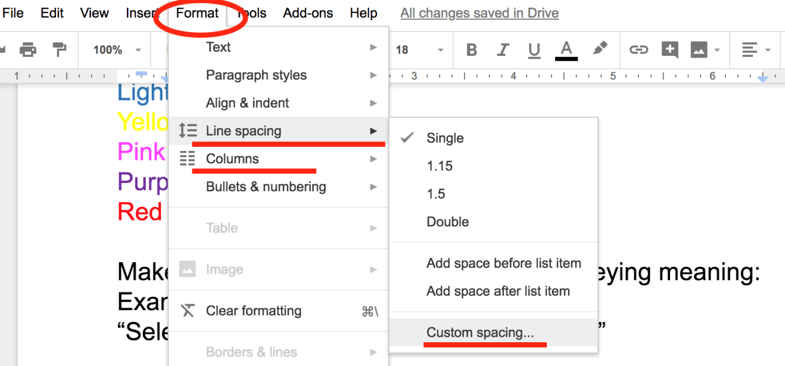

Headings How to achieve checklist item #7: Headings
Headings support document structure and can facilitate navigation for users of Assistive Technology. Therefore, all Headings must be concise, descriptive and structured using appropriate Heading levels.

Apply a Heading Style
Select text to be styled as a heading.
Select Format > Paragraph styles (See Figure 7).
Select the appropriate heading level (Heading 1 – 6) from the menu options.
Or use the Styles drop down menu, in the main toolbar.

Figure 7
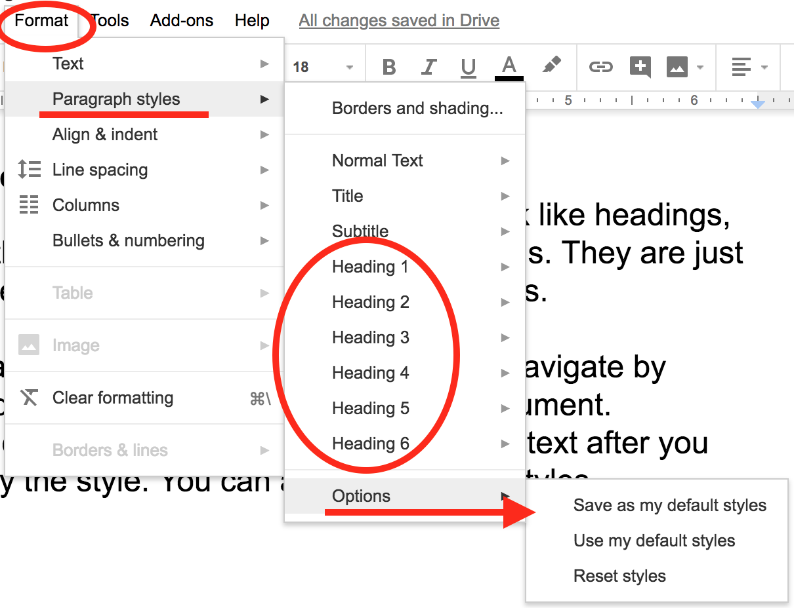

Modify Heading Style
Select the heading text to modify.
Choose the desired font attributes (size, color, etc.) using the formatting tools provided.
Select Format > Paragraph styles
Choose Update ‘Heading _’ to match from the Heading sub-menu. All instances of the applied Heading or chosen style will also be modified.
Note: Heading options can also be found under the Styles menu item in the Toolbar.
Custom Styles can be saved for future documents by selecting Format > Paragraph styles > Options > Save as my default styles.

How to achieve checklist item #8: Table of Contents (TOC)
Note: The document must have applied heading structure prior to creating a Table of Contents. Heading levels are used to create a nested list of contents, which can be used to facilitate document navigation by users of Assistive Technology.

Create a Table of Contents
Place your cursor where you would like the Table Of Contents.
Insert > Table of Contents > “With page numbers” (See Figure 8).
Figure 8
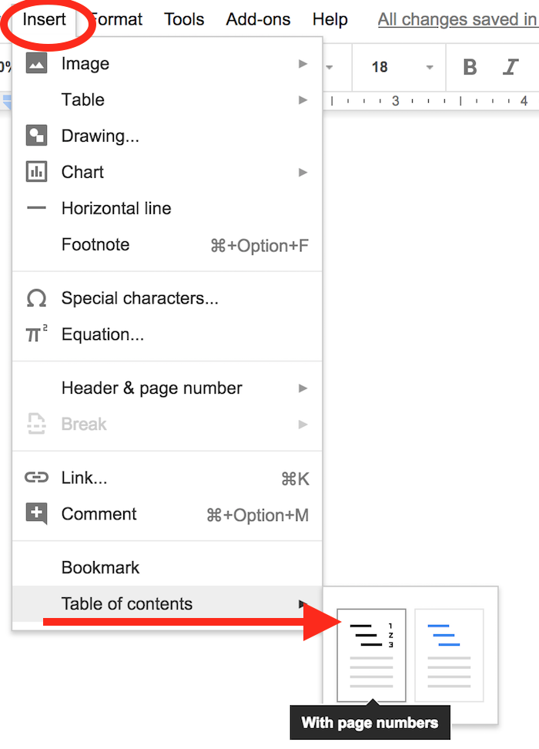
If changes are made later to the Heading structure, “right click” the TOC and choose Update table of contents or use the “Update table of contents” button provided.

How to achieve checklist item #9: Data Tables
Note: Accessible Tables cannot be created successfully in Google Docs.
Export your document and use authoring software tools such as Microsoft Word or Adobe Acrobat Pro to ensure an accessible Table.
Tables should not be used for layout purposes alone whenever possible, and must have assigned accessible Headers that repeat across pages. All table headers should include a “Scope” which provides context for screen reader users.
Tables should not allow rows to break across pages.
It is also recommended to give a Title or Caption to each Table and alt text that describes the organization of the Table (Refer to the “Word HowTo” document, for more information).

How to achieve checklist item #10: Hyperlinks

Make Text a Hyperlink
Select the text that will become a link.
Select Insert > Link.
In the Link text field type or paste a URL/web location or chose an existing document Heading/Bookmark to use as a destination for the link.
In the Text field, verify or modify the Text used to represent the link target.
Select the Apply button (See Figure 9).
Or highlight and right-click existing text to apply or modify a link.
Note: Link text should be concise, unique and should describe the topic or purpose of the link. Do not use link text such as “click here” or use the complete URL. Ensure that the appearance of link text is distinct from that of surrounding paragraph text, and does not use color alone as an indication of a link.

Figure 9
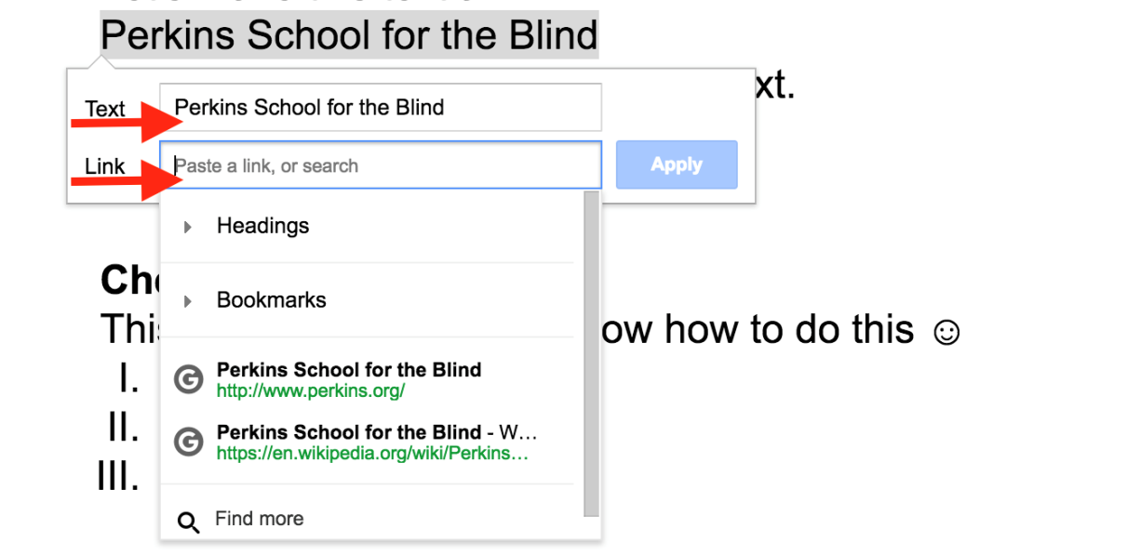

How to achieve checklist item #11: Lists
Note: Always create lists using the tools provided and not by manually formatting text.
Highlight text or position the cursor where you want to insert the bullet list.
In the Toolbar, select either the Numbered list or Bulleted list button and choose the preferred style from the sub-menu (See Figure 10).
Type and press enter to start the next bullet. Use the Tab key to create a nested list item.
To end the list, press enter/return twice.
Figure 10
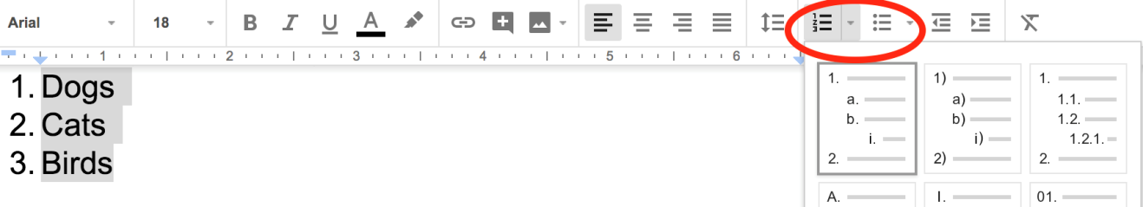

How to achieve checklist item #11: Images

Add Alternative Text to an Image
Right-click the image and choose Alt Text (See Figure 11).
In the “Description” field, enter concise, meaningful alternative text for the image.
Leave the Title field blank.
Note: The Description field within the Alt Text is most often read by popular screen readers. The Title field may not be read or may be unnecessarily verbose for some users.

Position your Image
A selected image presents users with a pop-up menu displaying options for image positioning, also known as “wrapping” (See Figure 11). Choose “In line” to ensure the image is placed in the proper reading order when exported, if “In line” cannot be selected, then it has already been applied.
Figure 11
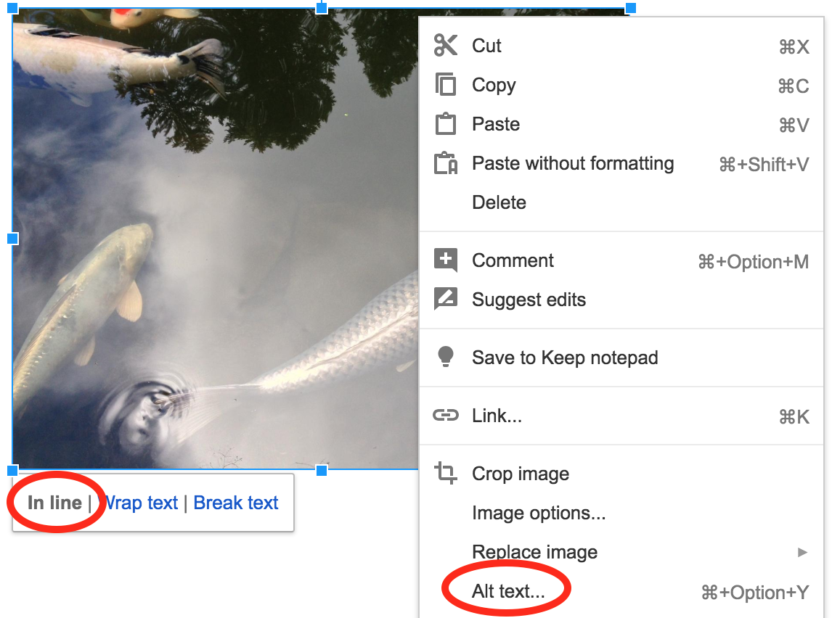

How to achieve checklist item #12: Charts & Graphs
Note: Accessible Charts and Graphs cannot be created successfully in Google Docs.
Export your document and use additional authoring software tools such as Microsoft Word to ensure an accessible Chart or Graph.
Remember that color-alone cannot be the only means of conveying information. Avoid using chart and graph styles that rely solely on color, use labels or fills so that a secondary visual characteristic is present to differentiate content.
It is recommended to give a Title or Caption to all Charts and Graphs as well as appropriate alternate text or data representation.

How to achieve checklist item #13: Forms
Note: Accessible Forms cannot be created successfully in Google Docs.
Export your document and use additional authoring software tools such as Adobe Acrobat Pro, to ensure an accessible Form.
It is strongly recommended to create accessible electronic forms in HTML or PDF format.

How to achieve checklist item #14: Export
Google Docs files can be exported to a variety of formats which include, Microsoft Word (.docx), Rich Text Format (.rtf), PDF (.pdf), and Plain Text (.txt).
File > Download as (See Figure 12)
Choosing a format from the menu begins the file download process.
Note: All documents should be checked for accessibility using the appropriate tools, before distribution.
Figure 12
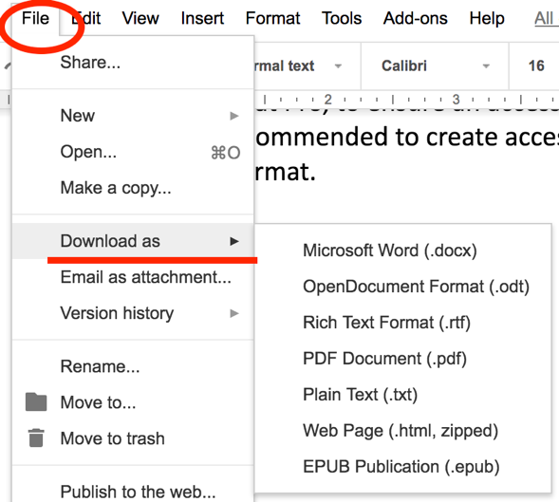

Additional Resources:
Make your document or presentation accessible
Google's accessibility features and products.
G Suite user guide to accessibility
Accessibility for Docs editors
Google Drive Help_Accessibility

