How to Create Accessible Documents in Microsoft Excel

How to achieve checklist item #1: Filename
File > Save OR CTL + S.
Enter a filename using the following rules:
- No spaces
- No special character (underscores and hyphens are okay)
- No unfamiliar abbreviations
Acceptable filename Examples:
- Survey_Results_09-01-2016.xlsx
- 2016_Budget.xlsx
- 2017_Projected_Revenue_v3.xlsx

How to achieve checklist item #2: File Properties

Set Author and Title
File > Info > Properties OR File > Properties
Enter Title and Author information (See Figure 1).
Figure 1
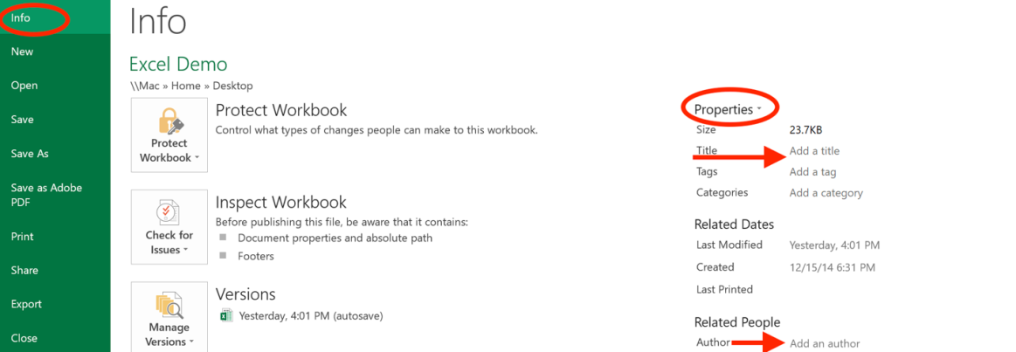
Set Document Language
File > Options > Language OR Tools > Language
Ensure that the correct language is selected for the document (See Figure 2).
Figure 2
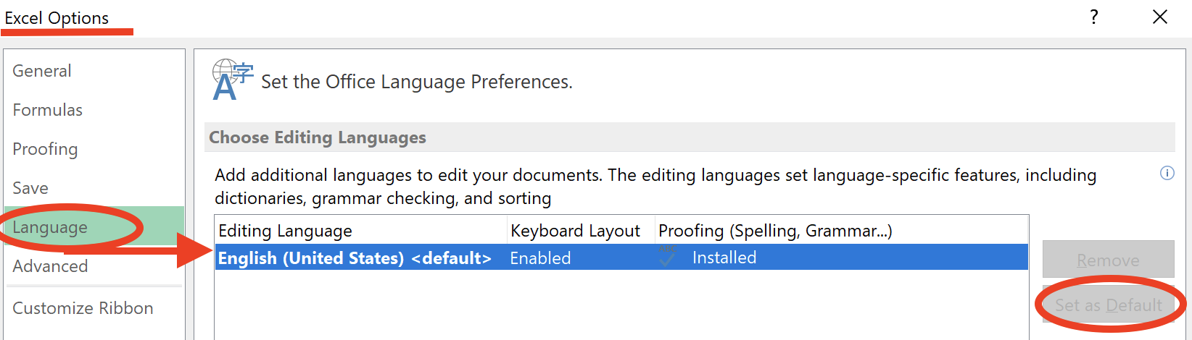

How to achieve checklist item #3: Text
File > Options > General OR, in some versions; Excel > Preferences > General.
In the “When creating new workbooks” section, select your font preferences.
Use a sans-serif font such as Arial, Helvetica, or Tahoma
It is recommended to use 12-point font size or larger whenever possible (See Figure 3).
Figure 3
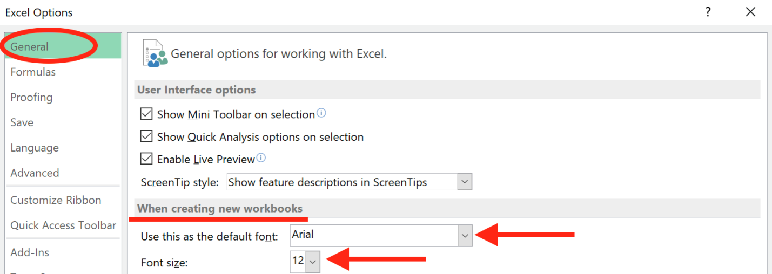

How to achieve checklist item #4: Color
Test contrast ratio using the Colour Contrast Analyzer.
Use a font color that has a color contrast ratio of 4.5:1 for 14 point font and smaller, and 3:1 for 14-point bold font or larger (See Figure 4).
When color is used to convey meaning or distinguish elements, (e.g. a cell with a colored background fill), a secondary characteristic must also be used.
In charts and graphs, text labels or a secondary visual characteristic (such as a pattern fill) must be used, (See checklist item #10).
Figure 4
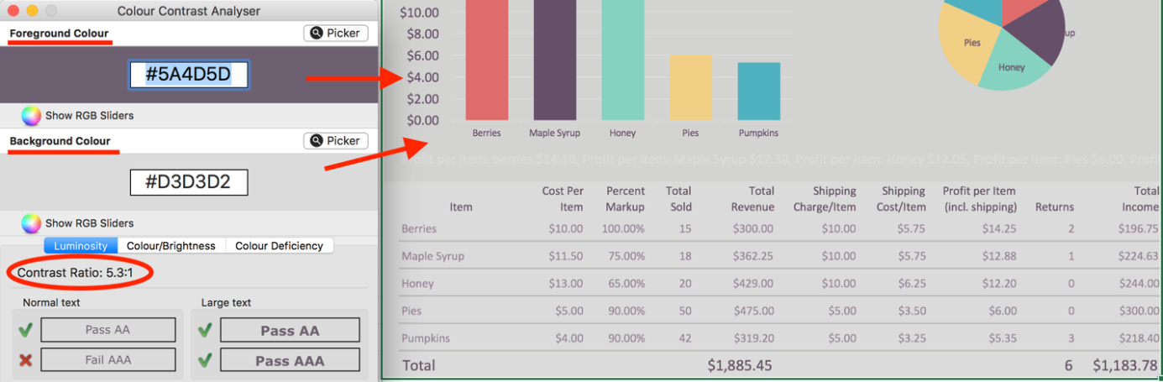

How to achieve checklist item #5: Titles

Sheet Title
“Right click” the sheet tab and choose “Rename”.
Enter a descriptive title for each tab (See Figure 5).
Figure 5
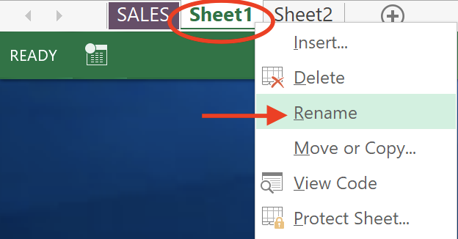

Table Title
For each table in a worksheet, enter a unique title above the table. Merging cells is okay.

How to achieve checklist item #6: Table Headers
Note: Before you begin, note the following:
- Number of tables on the sheet.
- Sheet number.
- Range of cells for the table (e.g. upper left cell to bottom right cell)
Place your cursor in the first cell of the table.
Formulas > Name Manager < New.
Figure 6
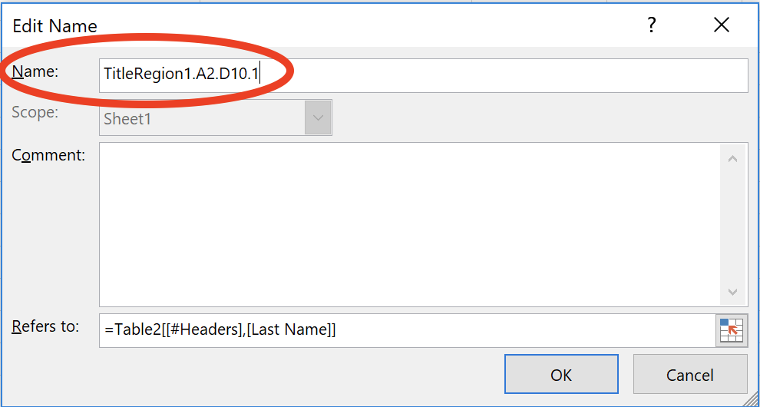
In the “Name” field, enter the following and fill in the placeholder fields (See Figure 6):
TitleRegion[tableNumber].[firstCell].[lastCell].[sheetNumber]
For example, if the table is the only table on the sheet, and is located on sheet 1, and has a range of A1 to D7, the formula would look like this:
TitleRegion1.a1.d6.1
If the same table were located on sheet 2, the formula would look like this:
TitleRegion1.a1.d7.2
Note: This formula assumes that your table has both column and row headers.
If your table only has column headers, use the following formula:
ColumnTitleRegion1.a1.d7.1
If your table only has row headers, use the following formula:
RowTitleRegion1.a1.d7.1
The following Formula can also be used to apply semantic column and row headings for screen readers: TitleRegion_Table[#]..[Last Cell]
replace [#] with the Table number and [Last Cell] with the last cell in the table such as D10.
Tables should not have more than one header row/column.

How to achieve checklist item #7: Cells
Avoid Merging Cells
Do not merge or spit cells containing data.

Avoid Blank Cells
Avoid leaving cells blank.

How to achieve checklist item #8: Hyperlinks

Use Unique Display Text for Links
Select the text that will become a link.
Press Control + K, or go to Insert > Hyperlink.
You can also “right-click on the selected text and choose “Hyperlink” from the menu.
Paste or enter the URL in the “Address” field. Select OK.

Use Unique Display Text for URLs
Navigate to the cell containing the URL, or select the URL.
Press Control + K, or go to Insert > Hyperlink.
Enter text in the “Text to Display” field. Select OK.

Add a Meaningful Screen Tip:
Right click the cell where the Hyperlink is located.
Select “Edit Hyperlink”.
Select “Screen Tip” button (See Figure 7).
Enter text that describes the destination of the link. Select OK.
Figure 7
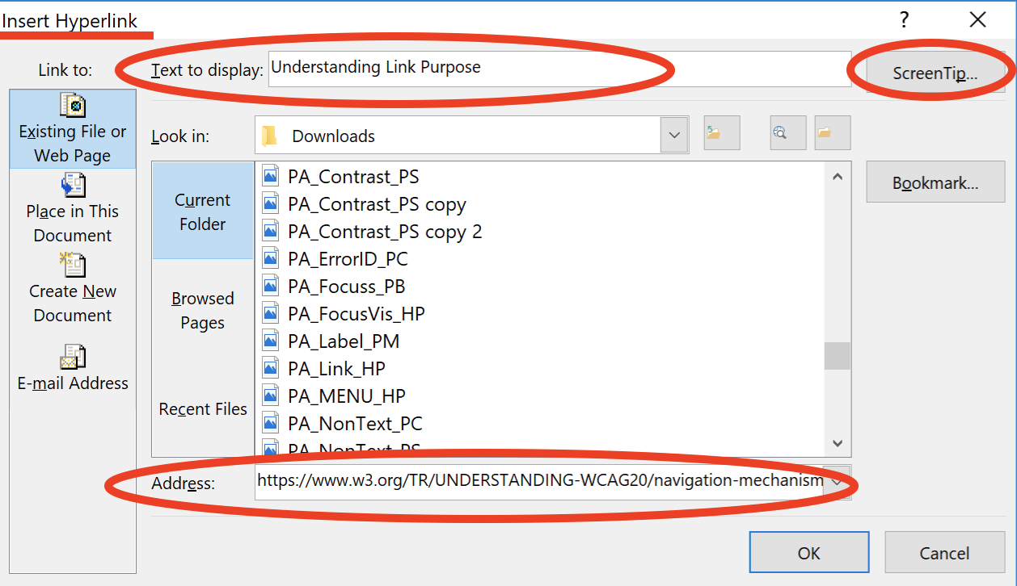

How to achieve checklist item #9: Images

Add Alternative Text to Images
Insert > Illustrations > Picture.
Select the Image.
“Right-click” on the image and select Format Picture.
Select “Size & Properties” icon.
Select “Alt text”.
In the “Description” field, enter a description of the image.
Leave the Title field blank (See Figure 8).

Figure 8
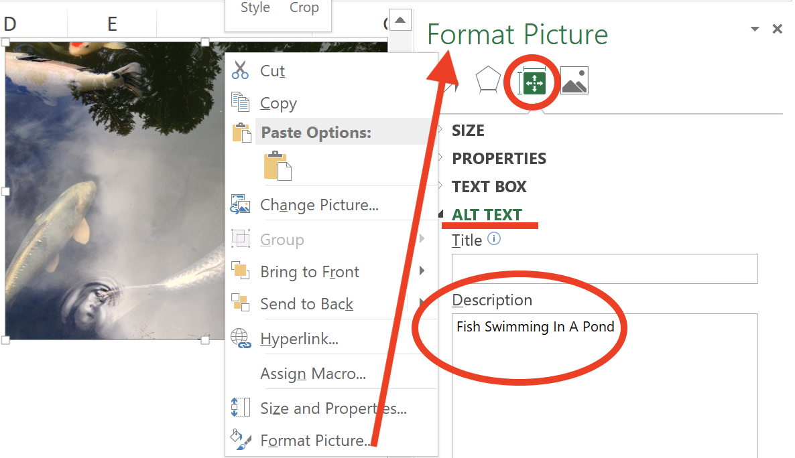

How to achieve checklist item #10: Charts & Graphs
Insert > Chart.
Choose your chart type.
When your chart is selected, the “Chart Tools” tab will appear.

Customize Chart Layout and Style
Chart Tools > Design > Quick Layouts.
Do not choose a chart layout that includes a data table. This table, which is embedded within the chart is not accessible.
For pie charts, choose a style in which labels are placed inside or adjacent to the pie slices.
Chart Tools > Design > Chart Styles (See Figure 9).

Figure 9
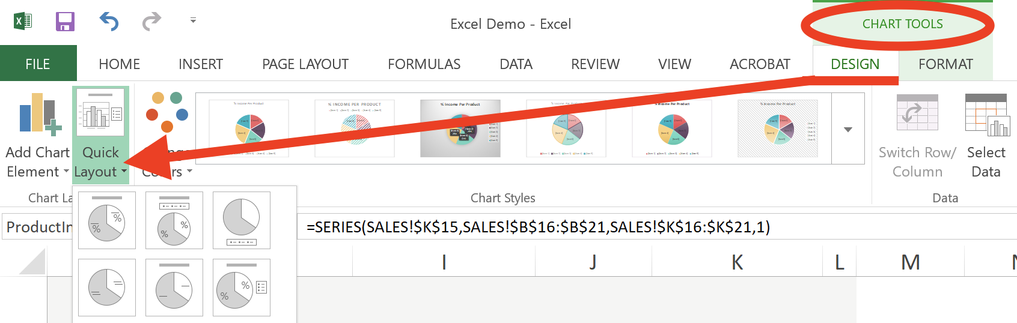
Note: Remember that color-alone cannot be the only means of conveying information. Avoid using chart and graph styles that rely solely on color. Use labels and/or pattern fills so that a secondary visual characteristic is present.
“Right-click” the Data Point or Series. Select the “Fill” icon that appears in the “Format Data Point (or Series) section, and choose the Pattern fill, Radio Button. Choose a Pattern that is distinguishable from neighboring chart items (See Figure 10).
Figure 10
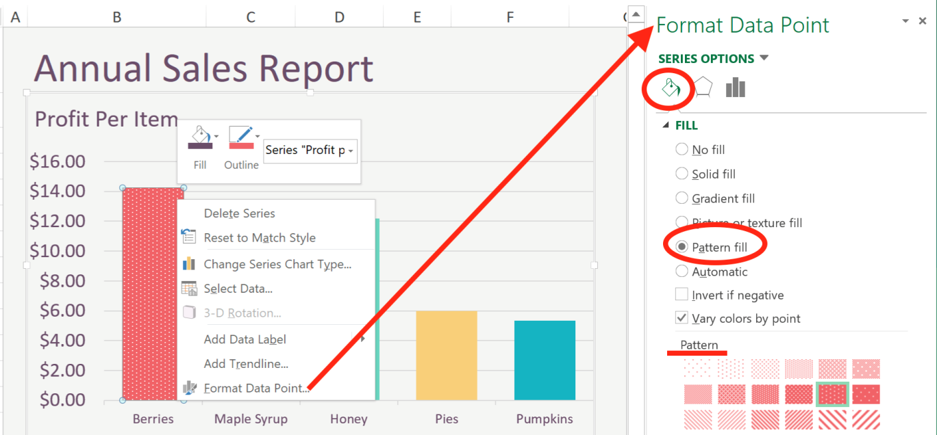

Add Alternative Text
Select the chart area.
“Right-Click” on the chart.
Select “Format Chart Area”.
Select the “Size and Properties” icon.
Select “Alt Text”.
In the “Title” field, type the title of the chart. In the “Description” field, direct users to the location of the text alternative that will present the equivalent information to screen reader users, do not use location-based language such as “to the right”. Text color can be used hide the text visually.
Note: Data that is presented in the chart should be presented using one of the following methods:
- Inform users that a text alternative of the chart is available within a subsequent sheet within the workbook. Present data as a table in a worksheet. Name the sheet appropriately (e.g. “Chart 2 Data”).
- Present data or text description in a cell adjacent to the chart. Identify the text as such (e.g. Text Description of Chart 2”).

How to achieve checklist item #11: Spacing
Resize a single blank row to create the desired space, and simply add the text “No Data” or “intentionally left blank” (See Figure 11). This text can be hidden by using a font color that matches the cell background color; i.e. white text in a white cell.
Figure 11
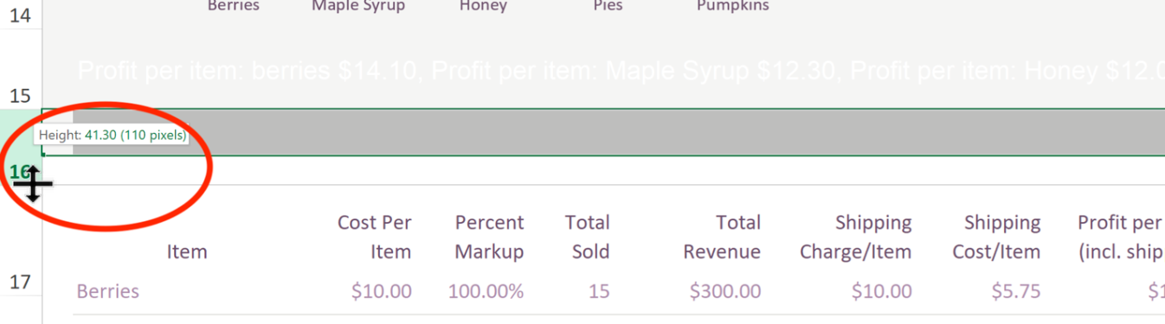

How to achieve checklist item #12: Peripheral Columns/Rows
Select the first blank column on your sheet.
Select Shift + end, then press right arrow.
This will select all peripheral columns.
Right-click on the selected columns and select “Hide” (See Figure 12).

Repeat these steps for blank rows using the down arrow.
Be sure to leave one blank row for “End of Worksheet” (See checklist item #13).
Figure 12
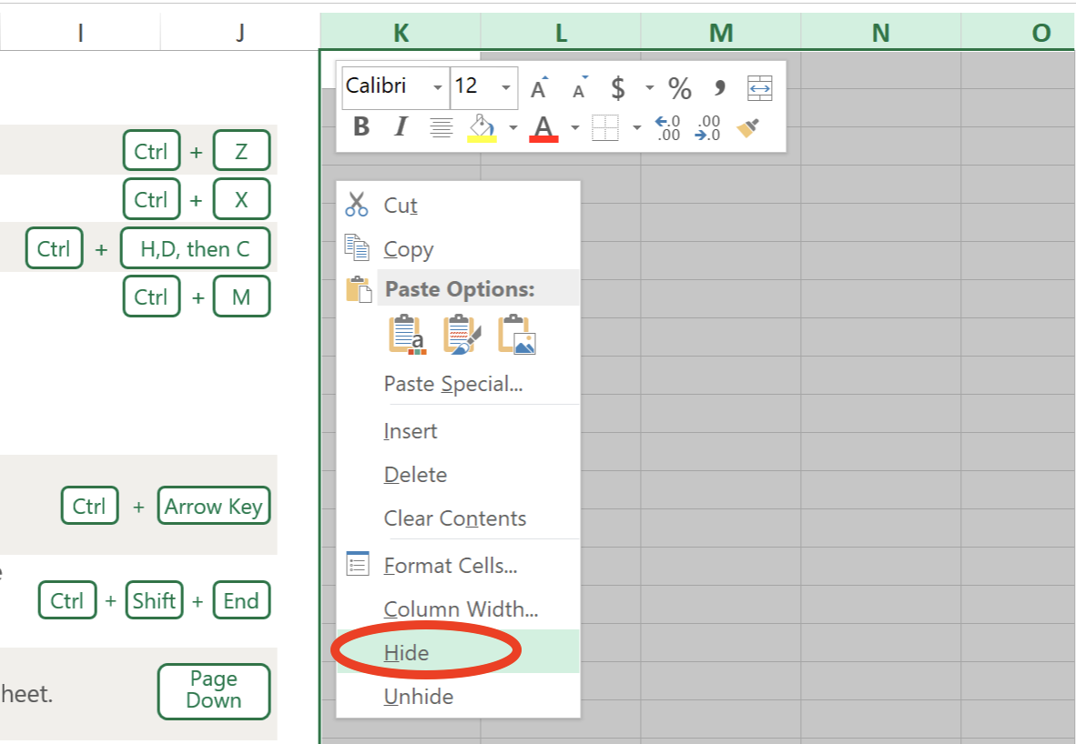

How to achieve checklist item #13: End of Worksheet

Define the End of the Worksheet
Use a row at the bottom of your Spreadsheet to let readers know they have reached the end of the sheet.
Merge cells in this row to the width of the worksheet area.
Enter “End of Worksheet” in the row.
The text can be hidden for aesthetic purposes, by using a font color that matches the cell background color (e.g. white text on a white background).

How to achieve checklist item #14: Print Area

Define Print Area
Select the cells that you would like to print.

Page Layout > Print Area > Set Print Area (See figure 13).
Figure 13
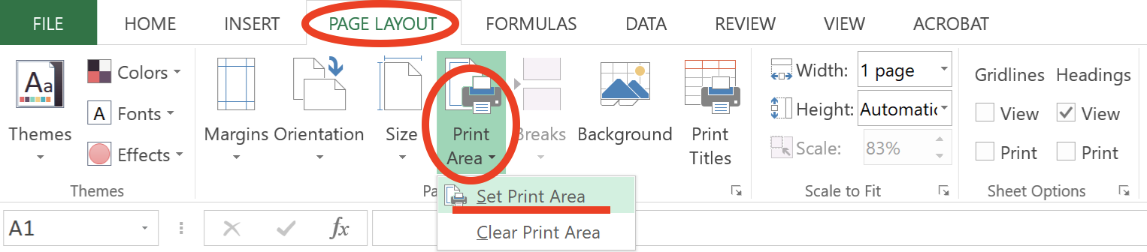

How to achieve checklist item #15: Check
File > Info < Check for Issues > Check Accessibility.
Accessibility Checker results will appear in a panel on the right side of the document (See Figure 14).
Correct all issues.
Figure 14
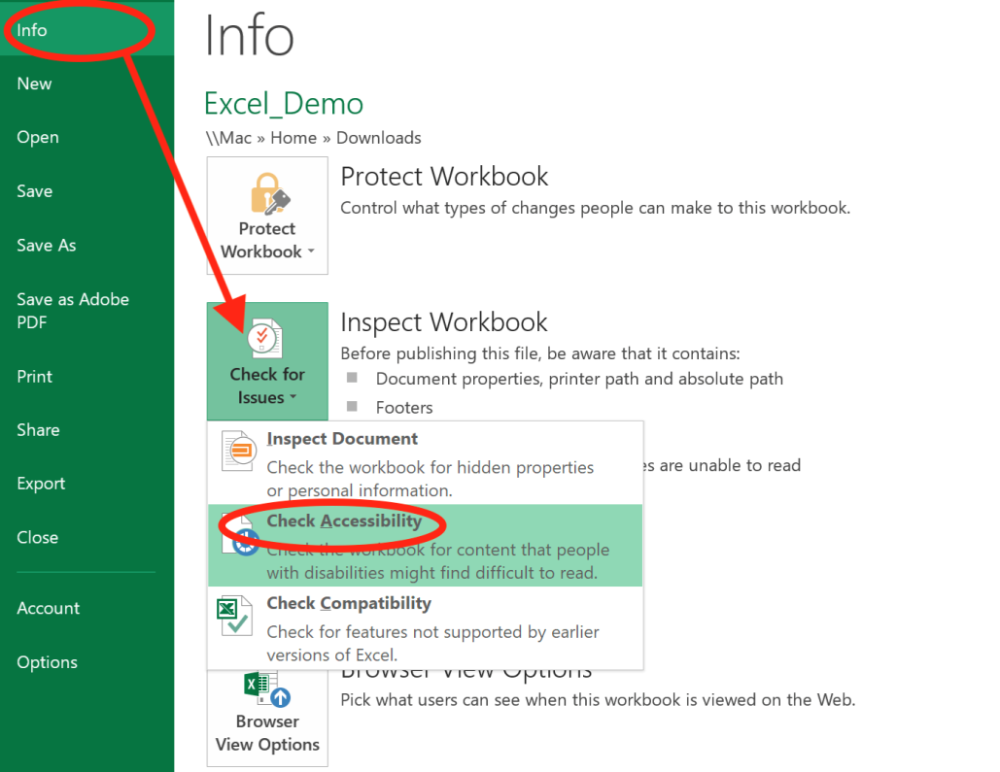

How to achieve checklist item #16: Convert to PDF

How to Convert MS Excel to PDF
- Begin by creating an accessible Excel document.
- Go to File > Export.
- Select Create PDF/XPS Document > Create PDF/XPS (button)
- Select “Options”.
- Check the following (See Figure 15):
- Document Properties
- Document Structure Tags for Accessibility.
- Select OK.
- Enter a concise, meaningful filename.
Figure 15
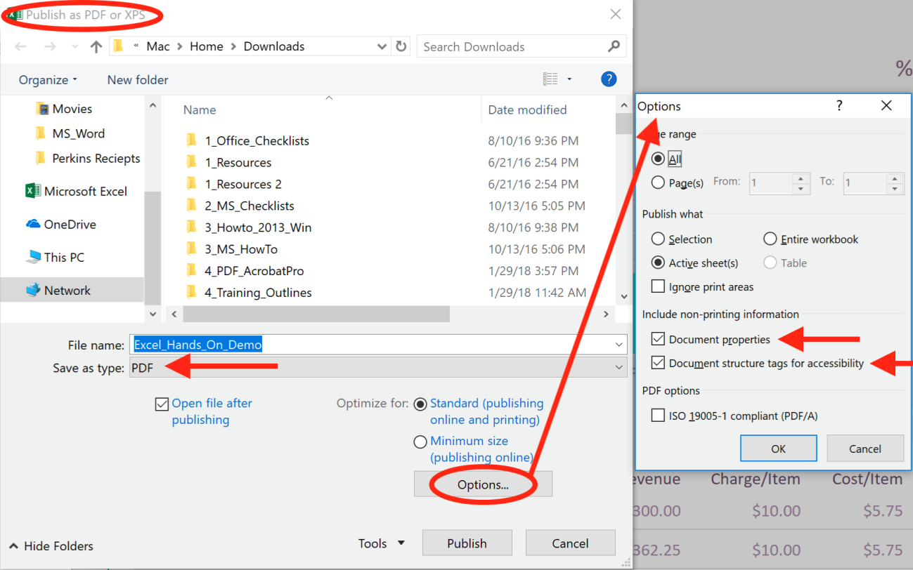
Note: Following these guidelines does not guarantee your PDF will meet all accessibility requirements. Check and remediate accessibility issues in Adobe Acrobat Pro DC to ensure that your PDF is fully accessible.

